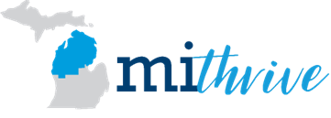

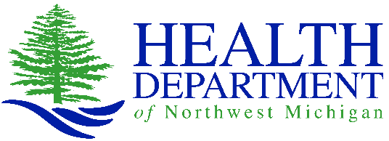
for Antrim, Charlevoix, Emmet & Otsego Counties
2021-2023 Community
Health Needs Assessment
Health Department of Northwest Michigan
September 2023
REPORT PREPARED BY
Emily Llore, MPH, Community Health Planner
Jane Sundmacher, M.Ed, Regional Planning Director
Chandra Gunjak, PhD, CDC Foundation, Covid-19 State Funded Program

Report feedback and questions can be sent to Janenne Irene Pung at j.pung@nwhealth.org.
Table of Contents

Message from the Health Officer 1
Executive Summary 1
Introduction 6
Mobilizing for Action Through Planning and Partnership Community Health Needs Assessment Framework 10
MiThrive Assessment Results 12
Community Health Status Assessment 12
Community Themes and Strengths Assessment 16
Community System Assessment 27
Forces of Change Assessment 30
Data Limitations 33
Identifying and Prioritizing Strategic Issues 35
Priority Area Narratives 39
Next Steps 39
Definitions 39
Acknowledgements 39

Appendices
- MiThrive Participating Organizations
- Community Health Status Assessment Survey Indicators and Scores
- Community Themes and Strengths Assessment Survey Instruments
- Community Themes and Strengths Assessment Community Assets
- Community System Assessment Event Agenda & Design
- Forces of Change Assessment Event Agenda & Design
- North Central, Northeast, and Northwest Strategic Issue Data Briefs
Message from the Health Officer
As a public health agency, the Health Department of Northwest Michigan (HDNW) exists to help promote health, prolong life, and prevent disease in our communities. To ensure the best use of tax dollars and public service, the Internal Revenue Service (IRS) mandates hospitals and healthcare organizations to complete a needs assessment for the communities they serve at least every three years.

HDNW serves the Northern Michigan counties of Antrim, Charlevoix, Emmet, and Otsego. The agency’s staff collaborates with regional hospital systems, other health departments, and community partners to create and distribute surveys to residents, to analyze data, and to produce the required reports to communicate findings on health status, quality of life, nonmedical factors that influence health outcomes, needs, mortality, and morbidity for each partner and region. This collaborative process increases efficiencies, decreases duplication of services, and improves the quality of data collected and used to address issues causing community health deficiencies.

The reports are called Community Health Needs Assessments, and this is our latest. It spans the years 2021-2023. Within this report, we describe:

• The current state of health and wellbeing for the region,
• The processes used to collect community perspectives, and
• The process for prioritizing strategic issues.
We also identify community strengths, resources, and service gaps for Antrim, Charlevoix, Emmet, and Otsego counties. The findings serve as the foundation for decisions on the effectiveness of our current programs and whether programs and services may need to be added to meet current needs.
Our regional results are part of a 31-county collaborative effort, known as MiThrive. Leaders from other Northern Michigan counties are also using their specific findings to best meet local needs.

With the Needs Assessment, MiThrive Workgroups spread over the 31 counites have developed and are integrating Community Health Improvement Plans to address areas of need. With the top-ranked priorities identified, this report provides the kind of data and analysis that leads to change – change that results in healthy, safe, and better-educated people who are equipped to improve their lives and be active, productive members of our communities.

Dan Thorell, Health Officer
Health Department of Northwest Michigan

Executive Summary
In a remarkable partnership, hospitals, health departments, and other community partners in Northern Michigan join together every three years to take a comprehensive look at the health and well-being of residents and communities. Through community engagement and participation across a 31-county region, the MiThrive Community Health Needs Assessment collects and analyzes data from a broad range of social, economic, environmental, and behavioral factors that influence health and well-being and identifies and ranks key strategic issues. In 2021, together we conducted a comprehensive, community-driven assessment of health and quality of life on an unprecedented scale. MiThrive gathered data from existing statistics, listened to residents, and learned from community partners, including health care providers. Our findings show our communities face complex interconnected issues and these issues harm some groups more than others.

Report Goals and Objectives
The purpose of this report is to serve as a foundation for community decision-making and improvement efforts. Key objectives include:
- Describe the current state of health and well-being in the HDNW jurisdiction
- Describe the processes used to collect community perspectives
- Describe the process for prioritizing Strategic Issues within the Northwest, and Northeast CHIR regions
- Identify community strengths, resources, and service gaps

Regional Approach
MiThrive was implemented across a 31-county region through a remarkable partnership of hospital systems, local health departments, and other community partners. Our aim is to leverage resources and reduce duplication while still addressing unique local needs for high quality, comparable county-level data. The 2021 MiThrive Community Health Needs Assessment utilized three regions: Northwest, Northeast, and North Central. We’ve found there are several advantages to a regional approach, including strengthened partnerships, alignment of priorities, reduced duplication of effort, comparable data and maximized resources.

Health Department of Northwest Michigan Jurisdiction by MiThrive Region
Northwest  Region | Northeast  Region
Antrim | Otsego
Charlevoix
Emmet

The Health Department of Northwest Michigan jurisdiction includes Antrim, Charlevoix, Emmet, and Otsego Counties which are in the Northwest, and Northeast CHIR Regions. As discussed in this report, of the four MiThrive assessments, two were conducted at the county level and two were conducted within the MiThrive regions.

Data Collection
MiThrive Data Collection in 31-County Region
100 Local, state, and national indicators collected by county for the Community Health Status Assessment
152 Participants in three Community System Assessment regional events
396 Participants in focused conversations for the Community System Assessment at 27 community collaborative meetings
3,465 Residents completed the Community Surveys for the Community Themes and Strengths Assessment
840 Residents facing barriers to social determinants of health participated in Pulse Surveys conducted by community partners for the Community Themes and Strengths Assessment
354 Physicians, nurses, and other clinicians completed Healthcare Provider Survey for the Community Themes and Strengths Assessment
199 Participants in three Forces of Change Assessment regional events

The findings detailed throughout this report are based on data collected through a variety of primary data collection methods and existing statistics. From the beginning, it was our goal to engage residents and many diverse community partners in data collection methods.
To accurately identify, understand, and prioritize strategic issues, MiThrive combines quantitative data, such as the number of people affected, changes over time, and differences over time, and qualitative data, such as community input, perspectives, and experiences. This approach is best practice, providing a complete view of health and quality of life while assuring results are driven by the community.
MiThrive utilizes the Mobilizing for Action through Planning and Partnerships community health needs assessment framework. Considered the “gold standard” it consists of four different assessments for a 360-degree view of the community. Each assessment is designed to answer key questions:
- Community Health Status Assessment
The Community Health Status Assessment identifies priority community health and quality of life issues. It answers the questions, “How healthy are our residents?” and “What does the health status of our community look like?”. The purpose of this assessment is to collect quantitative secondary data about the health and well-being of residents and communities. We collected about 100 statistics by county for the 31-county region from reliable sources such as County Health Rankings, Michigan Department of Health and Human Services, and US Census Bureau.

- Community System Assessment

The Community System Assessment focuses on organizations that contribute to wellbeing. It answers the questions, “What are the components, activities, competencies and capacities in the regional system?” and “How are services being provided to our residents?”. The Community System Assessment was completed in two parts. First, community-wide virtual meetings were convened in the Northwest, Northeast, and North Central MiThrive regions where participants discussed various attributes of the community system. These were followed by related discussions at community collaborative meetings at the county (or two-county) level.

- Community Themes and Strengths Assessment

The Community Themes and Strengths Assessment provides a deep understanding of the issues that residents feel are significant by answering the questions, “What is important to our community?”, “How is quality perceived in our community?”, and “What assets do we have that can be used to improve well-being?”. The Community Themes and Strengths Assessment consisted of three surveys: Community Survey, Healthcare Provider Survey, and Pulse Survey. Results from each were analyzed by county, hospital service area, and the three MiThrive Regions.

- Forces of Change Assessment

The Forces of Change Assessment identifies forces such as legislation, technology and other factors that affect the community context. It answers the questions, “What is occurring or might occur that affects the health of our community or the local system?”, and “What specific threats or opportunities are generated by these occurrences?”. Like the Community System Assessment, the Forces of Change Assessment was composed of community meetings convened virtually in the Northwest, Northeast, and North Central MiThrive Regions.
Each assessment provides important information, but the value of the four assessments is maximized by considering the findings as a whole.

Health Equity
The Robert Wood Johnson Foundation says health equity is achieved when everyone can attain their full health potential, and no one is disadvantaged from achieving this potential because of social position or any other socially defined circumstance. Without health equity, there are endless social, health and economic consequences that negatively impact patients/clients, communities, and organizations. Health equity can be viewed using different lenses such as race, culture, geographic location, available resources, and job availability to name a few. All of which can be significant contributors to increased mortality, lower life expectancy, and higher incidence of disease and disability, according to the Rural Health Information Hub.
The MiThrive Vision, a vibrant, diverse, and caring region where collaboration affords all people equitable opportunities to achieve optimum health and well-being, is grounded in the value of health equity. As one of the first steps of achieving health equity is to understand current health disparities, diverse community partners were invited to join the MiThrive Steering Committee, Design Team, and Workgroups and gathered primary and secondary data from medically underserved, minority, and low-income populations in each of the four MiThrive assessments, including—
- Cross-tabulating demographic indicators such as age, race, and sex, for the Community Themes and Strengths Assessment
- Engaging residents experiencing barriers to social determinants of health and organizations that serve them in the Community System Assessment, Community Themes & Strengths Assessment, and Forces of Change Assessment
- Reaching out to medically underserved and low-income population through Pulse Surveys administered by organizations that serve them
- Increasing inclusion of people with disabilities in the community health needs assessment through partnership with the Disability Network of Northern Michigan.
- Surveying providers who care for patients/clients enrolled in Medicaid Health Plans
- Recruiting residents experiencing barriers and diverse organizations that serve them to MiThrive Data Walks and Priority-Setting Events.

Key Findings
Following analysis of primary and secondary data collected during the 2021 MiThrive Community Health Assessment, 10-11 significant health needs emerged in each of the MiThrive Regions (North Central, Northeast, and Northwest). Members of the MiThrive Steering Committee, Design Team, and three Workgroups framed these significant health needs as Strategic Issues, as recommended by the Mobilizing for Action through Planning and Partnerships Framework.
In December 2021, residents and community partners participated in one of three regional MiThrive Data Walk and Priority Setting events. Using a criteria-based process, participants ranked the Strategic Issues as listed below. Severity, magnitude, impact, health equity, and sustainability were the criteria used for this ranking process.
Significant Health Needs by Region (unranked)
Health Needs | Northwest Region | Northeast Region
Access to Healthcare &  Chronic Disease Prevention | X | X
Economic Security | X | X
Equity | X | X
Housing Security | X | X
Mental Health | X | X
Safety and Well-Being | X | X
Substance Use | X | X
Transportation | X | X
Broadband Access | X
Food Security | X
Healthy Weight | X | X
COVID-19 |  | X

The purpose of this ranking process was to prioritize Strategic Issues to collectively address in a collaborative Community Health Improvement Plan. Following the Data Walk and Priority Setting Events, MiThrive partners and participants refined the prioritized Strategic Issues to remove any jargon, clarify language, and wordsmith.
The final top-ranked Strategic Issues in the Northeast Region are as follows:
- How do we increase access to quality substance use disorder services?
- How do we increase access to quality mental health services while increasing resiliency and wellbeing for all?
- How do we increase access to health care?
- How do we reduce chronic disease rates in the region?
The final top-ranked Strategic Issues in the Northwest Region are as follows:
- How do we ensure that everyone has safe, affordable, and accessible housing?
- How do we increase access to quality mental health and substance use disorder services while increasing resiliency and wellbeing for all?
- How do we increase access to health care?
- How do we reduce chronic disease rates in the region?
Introduction
We all have a role to play in our communities’ health. Many factors combine to determine the health of a community. In addition to disease, health is influenced by education level, economic status, and issues. No one individual, community group, hospital, agency, or governmental body can be responsible for the health of the community. No one organization can address complex community issues alone. However, working together, we can understand the issues, and create plans to address them.
A Model of How Health Happens
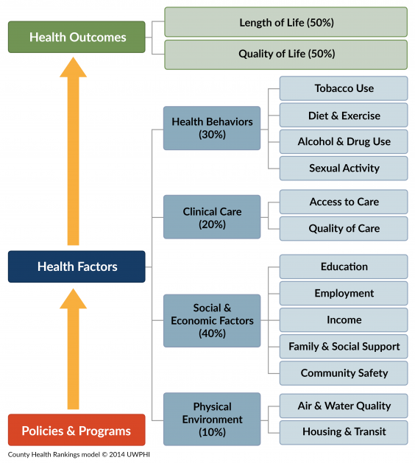
The County Health Rankings Model of How Health Happens provides a broad understanding of health, describing the importance of social determinants of health, organized in the categories of health behaviors, clinical care, social and economic factors, and the physical environment. It illustrates how community policies and programs influence health factors and in turn, health outcomes.
Purpose of Community Health Needs Assessment
The foundation of the MiThrive community health needs assessment is the County Health Rankings Model and its focus on social determinants. The purpose of the community health needs assessment is to:
- Engage residents and community partners to better understand the current state of health and well-being in the community.

- Identify key problems and assets to address them. Findings are used to develop collaborative community health improvement plans and implementation strategies and to inform decision-making, strategic planning, grant development, and policy-maker advocacy.
Role of MiThrive Steering Committee, Design Team, and Work Groups
The MiThrive Design Team is responsible for developing data collection plans for the four assessments and proposing recommendations to the Steering Committee. In addition to approving the Data Collection Plans, the Steering Committee updated the MiThrive Vision and Core Values and provided oversight to the community health needs assessment. The regional Workgroups (Northwest, Northeast, and North Central) assisted in local implementation of primary data collections, participated in assessments and Data Walk and Priority-Setting Events. They will develop a collaborative Community Health Improvement Plan for the top-ranked priorities in their regions and oversee their implementation. (Please see Appendix A for list of organizations engaged in MiThrive in the North Central, Northwest, and Northeast Regions).
Impact of COVID-19 on MiThrive
There were challenges in conducting a regional and collaborative community health needs assessment in 2021 during the peak of the COVID-19 pandemic. Despite their roles in pandemic response, leaders from hospitals, health departments, and other community partners prioritized their involvement in planning and executing the MiThrive Community Health Needs Assessment through their active participation in the Steering Committee, Design Team, and/or one or more regional Work Groups. In all, 53 individuals representing 40 organizations participated in the MiThrive organization.
In previous cycles of community health needs assessment, MiThrive convened in-person events for the Community System Assessment and Forces of Change Assessment. During the pandemic, they were convened virtually using Zoom and participatory engagement tools like breakout rooms, MURAL and RetroBoards, among others. Because residents and partners did not have to spend time and travel, their participation at the community assessment events was increased. Overall, 5,406 people participated in MiThrive primary data collection activities.
Mobilizing for Action through Planning and Partnerships

MiThrive utilizes the Mobilizing for Action through Planning and Partnership (MAPP) community health needs assessment framework. It is a nationally recognized, best practice framework that was developed by the National Association of City and County Health Officials (NACCHO) and the U.S. Centers for Disease Control and Prevention (CDC).
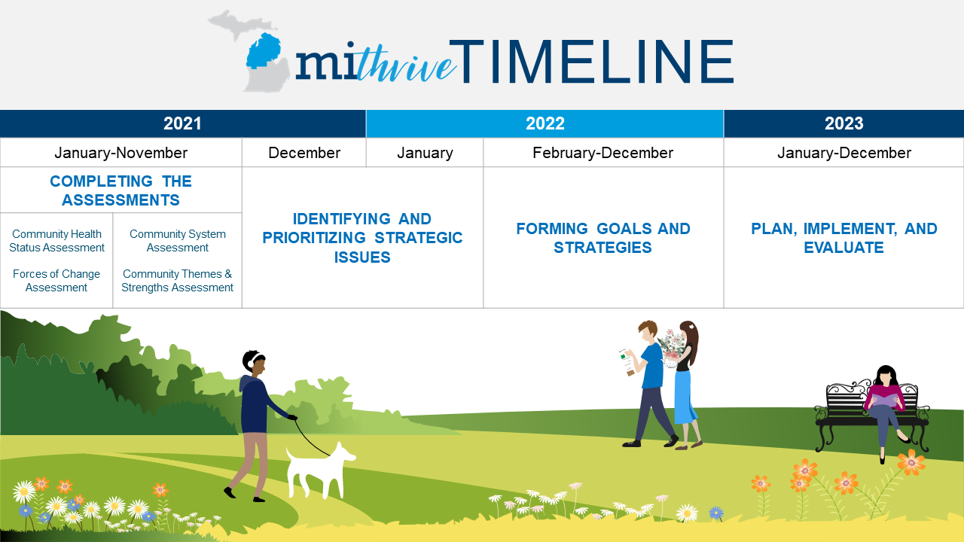
Organizing and Engaging Partners
Phase 1 of the MAPP Framework involves two critical and interrelated activities: organizing the planning process and developing the planning process. The purpose of this phase is to structure a planning process that builds commitment, encourages participants as active partners, uses participants’ time well and results in a Community Health Needs Assessment that identifies key issues in a region to inform collaborative decision making to improve population health and health equity, while at the same time, meeting organizations’ requirements for community health needs assessment. During this phase, funding agreements with local health departments and hospitals were executed, the MiThrive Steering Committee, Design Team, and Workgroups were organized, and the Core Support Team was assembled.
Conducting the Four Assessments
The MAPP framework consists of four different assessments, each providing unique insights into the health of the community. For the 2021 community health needs assessment the MiThrive gathered more health equity data than ever before, and engaged more diverse stakeholders, including many residents, in the assessments (Please see Appendix A for list of organizations that participated in MiThrive).
Health Equity
Health equity is the realization of all people of the highest attainable level of health. Achieving health equity requires valuing all individuals and populations equally and entails focused and ongoing societal efforts to address avoidable inequities by ensuring the conditions for optimal health for all groups.
--Adewale Troutman
Health Equity, Human Rights and Social Justice: Social Determinants as the Direction for Global Health

There is more to good health than health care. Several factors affect people’s health that people do not often think of as health care concerns, like where they live and work, the quality of their neighborhoods, how rich or poor they are, their level of education, or their race or ethnicity. These social factors contribute greatly to individuals’ length of life and quality life, according to the County Health Rankings Model.
A key finding of the 2021 MiThrive community health needs assessment mirrors a persistent reality across the country and the world: health risks do not impact everyone in the same way. We consistently find that groups who are more disadvantaged in society also bear the brunt of illness, disability, and death. This pattern is not a coincidence. Health, quality of life, and length of life are all fundamentally impacted by the conditions in which we live, learn, work, and play. Obstacles like poverty and discrimination lead to consequences like powerlessness and lack of access to good jobs with fair pay, quality education and housing, safe environments, and healthcare. All these community conditions combine to limit the opportunities and chances for people to be healthy. The resulting differences in health outcomes (like risk of disease or early death) are known as “health inequities”.
The health equity data collected in the four MiThrive assessments is discussed below.

MiThrive Assessment Results
- Community Health Status Assessment

The Community Health Status Assessment identifies priority community health and quality of life issues. It answers the questions, “How healthy are our residents?” and “What does the health status of our community look like?”. The answers to these questions were measured by collecting 100 secondary indicators from different sources including the Michigan Department of Health and Human Services, US Census Bureau, and US Centers for Disease Control and Prevention.

The Design Team assured secondary data included measures of social and economic inequity, including: Asset-Limited, Income-Constrained, Employed (ALICE) households; children living below the Federal Poverty Level; families living below the Federal Poverty Level, households living below Federal Poverty Level; population living below Federal Poverty Level; gross rent equal to or above 35% of household income; high school graduation rate; income inequality; median household income; median value of owner-occupied homes, political participation; renters (percent of all occupied homes); and unemployment rate.
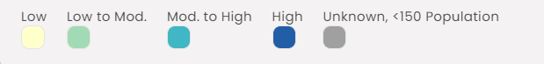
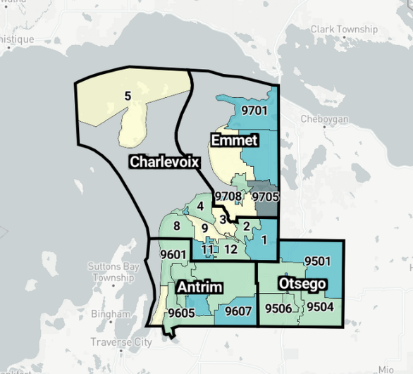
Social Vulnerability Index by Census Tract in the HDNW Jurisdiction
Source: Michigan Lighthouse 2022, Centers for Disease Control and Prevention/ Agency for Toxic Substances and Disease Registry/ Geospatial Research, Analysis, and Services Program. CDC Social Vulnerability Index 2018 Database - Michigan..

The Social Vulnerability Index illustrates how where we live influences health and well-being. It ranks 15 social factors: income below Federal Poverty Level; unemployment rate; income; no high school diploma; aged 65 or older; aged 17 or younger; older than five with a disability; single parent households; minority status; speaks English “less than well”; multi-unit housing structures; mobile homes; crowded group quarters; and no vehicle.
As illustrated in the map at right, census tracts in the HDNW jurisdiction have Social Vulnerability Indices at “low to moderate” or “moderate to high” in most of the district.

Community Health Status Assessment indicators were collected and analyzed by county for MiThrive’s 31-county region from the following sources:

  - County Health Rankings
  - Feeding America
  - Kids Count
  - Michigan Behavioral Risk Factor Surveillance Survey
  - Michigan Cancer Surveillance Program
  - Michigan Care Improvement Registry
  - Michigan Health Statistics
  - Michigan Profile for Healthy Youth
  - Michigan School Data
  - Michigan Secretary of State
  - Michigan Substance Use Disorder Data Repository
  - Michigan Vital Records
  - Princeton Eviction Lab
  - United for ALICE
  - U.S. Census Bureau
  - U.S. Health Resources & Services Administration
  - U.S. Department of Agriculture

Each indicator was scored on a scale of one to four by sorting the data into quartiles based on the 31-county regional level, comparing to the mean value of the MiThrive Region, and comparing to the State, national, and Healthy People 2030 target when available. Indicators with a score above 1.5 were defined as “high secondary data” and indicators with scores below 1.5 were defined as “low secondary data”.
The following 14 statistics scored above 1.5 across all counties in the HDNW jurisdiction, indicating they were worse than the National overall or State rates:

  - Teens with 5+ fruits/veg per day
  - Pneumonia
  - Intentional Self-Harm
  - SNAP-authorized stores/1,000 pop
  - Smoked cigarettes in past 30 days (teens)
  - Vaped in past 30 days (teens)
  - Alzheimer's/Dementia
  - Used marijuana in past 30 days (teens)
  - Had a drink of alcohol in past 30 days (teens)
  - Used chew tobacco etc. in past 30 days (teens)
  - Income inequality
  - Major depressive episode (teens)
  - Number of Evictions (rate)
  - Overweight(adults)

Please see Appendix B for values for these indicators for each county within the HDNW jurisdiction.

Geography and Population Rurality by County

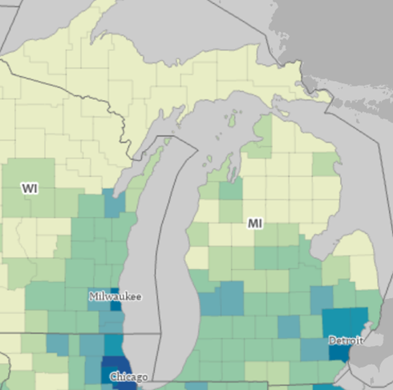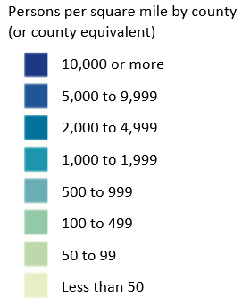
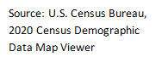

Population and age: Total population in 2019 for each county ranges from 23,324 in Antrim County to 33,415 in Emmet County. When broken down by age group, Antrim County has the lowest percent of people under age 5 (4.2%) and Otsego has the highest at 5.2%. All four counties have a lower percentage of residents under age 5 than Michigan. In the under 18 age group, Antrim County has the lowest percent at 17.7% and all four counties have a lower percentage of residents in that age ranged compared with the rest of Michigan. All four counties have higher percentages of individuals aged 65 and over compared to the Michigan rate of 17.7%, ranging from 21.7% in Otsego County to 28% in Antrim County.

The composition of the population is also important, as health and social issues can impact groups in different ways, and different strategies may be more appropriate to support these diverse groups. All four counties in the Health Department Northwest jurisdiction are predominately White, with the highest percentage in Antrim County (94.4%). The highest percentage of black residents in the jurisdiction are reported in Emmet County (0.7%). The highest percent of Hispanic population is found in Antrim County (2.5%). The highest percent of American Indian population is reported in Emmet County (3.8%). Within the HDNW jurisdiction, Little Traverse Bay Bands of Odawa Indians, a Native Sovereign Nation, is based in Emmet. (https://ltbbodawa-nsn.gov/)

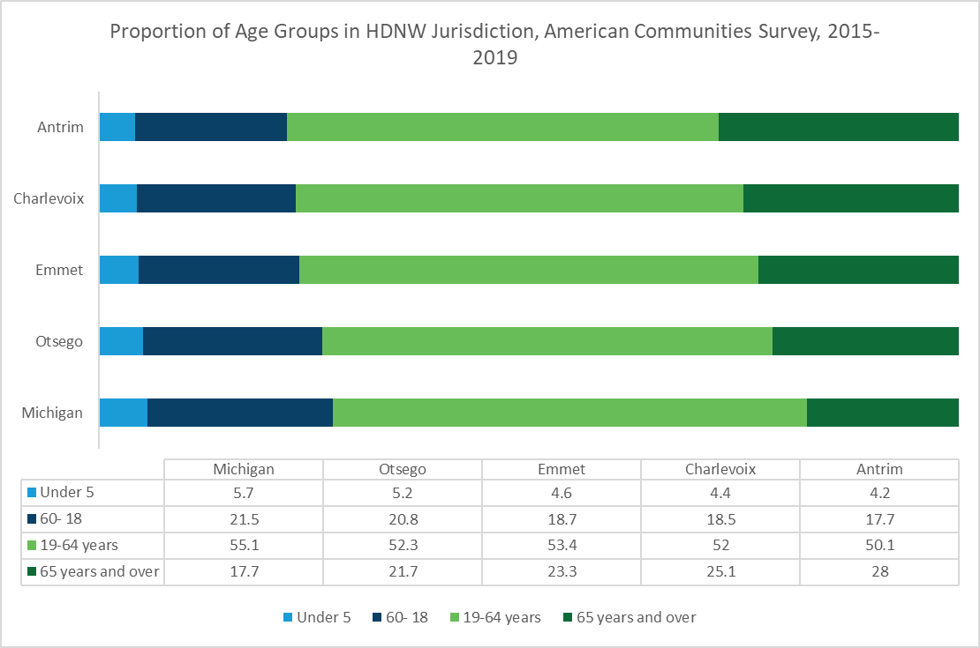
All counties within the HDNW jurisdiction have a higher proportion of adults over the age of 65 than Michigan overall.

Emmet County has a higher proportion of American Indian and Alaskan Native populations when compared to the other HDNW counties.

The Michigan Behavioral Risk Factor Survey (BRFSS) asked adults within all HDNW counties if a medical professional has ever told them they had diabetes (among other questions). HDNW overall had 12.7% of its resident’s report being told they had diabetes. Antrim (11.8%) and Otsego (17%) have the highest prevalence while Charlevoix (9%) had the lowest. For adults reporting having poor mental health for at least 14 days of the previous month, Antrim and Emmet Counties (12.7% respectively) had the highest prevalence. Data for this health indicator was suppressed for Otsego County. Antrim County had the highest rate of adults who had ever been told that they had COPD (12.3%).

All HDNW counties have a high prevalence of individuals who are overweight or obese. The BRFSS shows that Emmet (42.4%) and Charlevoix (35.1%) Counties have the highest prevalence of obesity in the jurisdiction. While Charlevoix (41.2%) and Otsego (41%) Counties have the highest prevalence of individuals who are overweight. District-wide prevalence of individuals who are overweight and obese continue to increase year after year. This partially contributes to the next indicator, self-reported general health. For this indicator, 21.1% of the Health Department Northwest jurisdiction reported having poor or fair general health. Emmet County had the highest prevalence of poor or fair general health at 27.4%.

In 2018, Charlevoix County had the lowest of all cancer incidence at 410.52 new cases per year per 100,000 residents while Otsego County had the highest incidence at 442.88. Michigan’s incidence is 449.6 while HDNW overall is slightly lower at 426.56. Within the HDNW jurisdiction, all counties (Antrim, Charlevoix, Emmet, and Otsego) have cancer incidence rates lower than the state. HDNW has lower breast and colorectal cancer incidence rates compared to the state. For breast cancer, counties within HDNW jurisdiction have rates lower than Michigan’s rate of 65.7 new cases per year per 100,000 residents. For colorectal cancer, two out of four counties are higher than Michigan’s incidence rate of 37.3: Charlevoix at 37.8, and Otsego at 42.3. The HDNW jurisdiction has a lower incidence rate than the state at 52.8 to 59.8 for lung and bronchus cancers, which showed that Lake County has the highest rate at 59.8 followed by Antrim at 53.6. For oral cavity and pharynx cancer, HDNW has a higher incidence rate, overall, than the state at 13.2. Otsego has the highest incidence at 15.1.

HDNW Jurisdiction Mortality Rates by Census Tract Poverty Level
MDHHS Vital Statistics, 2019
 |  | Poverty Level by Census Tract
 |  | 0.0% - 4.9% of Population in Poverty | 5.0% - 9.9% of Population in Poverty | 10.0% - 19.9% of Population in Poverty | 20.0% - 100% of Population in Poverty
Age-Adjusted Mortality Rates (per 100,000) | Michigan | 647.7 | 710.3 | 780.6 | 987.8
 | HDNW  (calculated) | 120.9 | 453.5 | 610.8 | 615
 | Antrim | 0.0 | 188.3 | 485.7 | 536.6
 | Charlevoix | 0.0 | 427.8 | 591.5 | 432.7
 | Emmet | 0.0 | 561 | 548.5 | 838.1
 | Otsego | 0.0 | 586.7 | 255.3 | 0.0

This table displays mortality rates as the number of deaths per 100,000 population for the 2019 year in the HDNW jurisdiction, separated by poverty level of the census tract for which each resident who passed away lived. Poverty level groups show the percentage of census tract population that falls under the poverty line. The most affluent track has the least amount of people living below the poverty line (0.0% - 4.9%) and the less affluent tracts have the highest percent of people living below the poverty line (20.0% to 100%), where at least 1/5 of the population falls under the poverty line. From this table, the mortality for the 0% to 4.9% poverty group is suppressed for HDNW due to the low number of individuals who fall into the more affluent category. The highest mortality rate (615 deaths per 100,000) within the HDNW jurisdiction is in the lowest poverty category of 20% to 100%, which demonstrates a higher rate of mortality as the amount of people living in poverty increases.

Approximate Mortality Rates by Race and Sex for the HDNW Jurisdiction Service Area
MDHHS Vital Statistics, 2020
 | Black Mortality Rate (per 100,000) |  |  | White Mortality Rate (per 100,000) |  |  | Other Mortality Rate (per 100,000)
 | Total | Male | Female | Total | Male | Female | Total | Male | Female
Michigan | 1260.0 | 1410.0 | 1130.0 | 1190.0 | 1230.0 | 1140.0 | 380.0 | 400.0 | 370.0
Overall  (Calculated) | * | * | * | 1275.4 | 1371 | 1445.2 | 229.8 | 232 | 227.5
Antrim | * | * | * | 1330.0 | 1480 | 1180 | 1020 | 1030 | 1010
Charlevoix | * | * | * | 1340 | 1350 | 1240.0 | * | * | *
Emmet | * | * | * | 1110 | 1190 | 1530.0 | * | * | *
Otsego | * | * | * | 1350 | 1490 | 1510.0 | * | * | *
*Suppressed due to low mortality counts
In Michigan, the crude mortality rate for individuals who are black is higher than for individuals who are white; however, in HDNW, there is a higher mortality rate for white individuals than black. Of note, residents that fall into the “Other” category have a lower mortality rate than residents who identify as white. Much of the data on individuals who fall into the “Other” category is suppressed due to low numbers. Males have a higher mortality rate than females in HDNW for both white and black categories.

Approximate Mortality Rate by Gender for HDNW and Michigan
MDHHS Vital Statistics, 2020

 | Male  Mortality Rate (per 100,000) | Female Mortality Rate (per 100,000) | Total
Michigan | 1084.3 | 822.9 | 951.6
Overall  (Calculated) | 788.4 | 643.9 | 716.5
Antrim | 757.8 | 596.8 | 677.1
Charlevoix | 790.7 | 599.4 | 696.4
Emmet | 919 | 567.5 | 746.4
Otsego | 1311.5 | 1114.9 | 1212.5

Mortality Rates for Males by Age Group in HDNW and Michigan
MDHHS Vital Statistics, 2020

Males Only Mortality Rate (per 100,000) | <1-14 Age Mortality (per 100,000) | 15-29 | 30-39 | 40-49 | 50-59 | 60-69 | 70=<
Michigan | 55.1 | 134.8 | 285.9 | 435.1 | 890.0 | 1973.0 | 7518.1
Overall | 23.13 | 77.18 | 442.80 | 101.44 | 952.03 | 1532.60 | 5986.55
Antrim | 0 | 113.6 | 467.7 | 330.0 | 2.6 | 1306.5 | 5621.3
Charlevoix | 0 | 141.4 | 377.1 | 439.9 | 1084.3 | 1114.2 | 4732.5
Emmet | 36.8 | 33.9 | 405.6 | 253.0 | 695.3 | 1519.1 | 6686.4
Otsego | 47.2 | 89.6 | 538.9 | 366.8 | 1070.3 | 2373.7 | 9262.9

Mortality Rates for Females by Age Group in HDNW and Michigan
MDHHS Vital Statistics, 2020

Females Only Mortality Rate (per 100,000) | <1-14 Age Mortality (per 100,000) | 15-29 | 30-39 | 40-49 | 50-59 | 60-69 | 70=<
Michigan | 50.1 | 58.4 | 145.6 | 425.9 | 521.0 | 1831.2 | 5664.5
Overall | 49.27 | 59.20 | 82.90 | 347.16 | 803.95 | 1151.11 | 5661.65
Antrim | 63.1 | 0 | 0 | 167.5 | 394.1 | 548.9 | 5144.4
Charlevoix | 97.8 | 50.3 | 78.3 | 212.9 | 491.9 | 357.3 | 4811.2
Emmet | 41.3 | 107.8 | 163.8 | 102.2 | 628.2 | 682.3 | 4088.8
Otsego | 0 | 48.8 | 226.6 | 212.8 | 576.5 | 1484.6 | 9398.1

Out of all HDNW counties, Otsego has the highest mortality rate, followed closely by Emmet. In all HDNW counties, males have a higher mortality rate than females.
Of the counties with available data, all four counties within the HDNW jurisdiction have a lower male mortality rate than Michigan for ages less than 1 to 14 years. Additionally, only Charlevoix County has a male mortality rate higher than Michigan for ages 15-29. Otsego has the highest mortality rate for males ages 30-39 and Charlevoix has the highest mortality rate for males ages 40-49. Two counties, Antrim and Charlevoix have a higher female mortality rate than Michigan for ages less than 1 to 14 years old. Additionally, Emmet County has a higher female mortality rate than Michigan for ages 15-29. Charlevoix has the highest mortality rate for males ages 30-39 as well as the highest mortality rate for males ages 40-49.

- Community Themes and Strengths Assessment
The Community Themes and Strengths Assessment provides a deep understanding of the issues that residents feel are significant by answering the questions, “What is important to our community?”, “How is quality perceived in our community?”, and “What assets does our community have that can be used to improve well-being?” For the Community Themes and Strengths Assessment, the MiThrive Design Team designed three types of surveys: Community Survey, Healthcare Provider Survey, and Pulse Survey.
(Please see Appendix D for survey instruments).
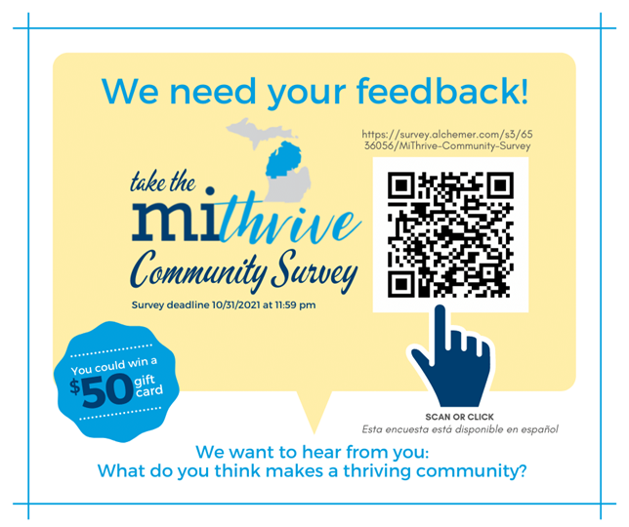
- Community Survey
The Community Survey asked 18 questions about what is important to the community, what factors are impacting the community, quality of life, built environment, and demographic questions. The Community Survey also asked respondents to identify assets in their communities. Please see Appendix C for assets identified for Antrim, Charlevoix, Emmet, and Otsego Counties.

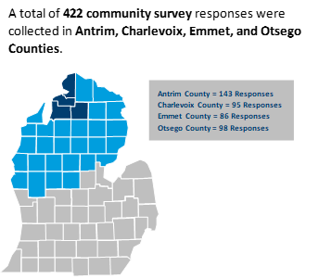
Community Surveys were administered electronically and via paper format in both English and Spanish. The electronic version of the survey was available through an electronic link and QR code. The survey was open from Monday, October 4, 2021, to Friday, November 5, 2021.

Five $50 gift cards were used as an incentive for completing the survey. Partner organizations supported survey promotion through social media and community outreach. Promotional materials developed for Community Survey include a flyer, social media content, and press release. Four hundred twenty-two surveys were collected from Antrim, Charlevoix, Emmet, and Otsego Counties.

Individuals aged 18-24 make up a larger proportion of those who thought disease and illness prevention was an important factor for a thriving community in comparison to the other nine top factors.

Individuals with a yearly household income of up to $39,999 make up a larger proportion of those who thought reliable transportation was an important factor for a thriving community in comparison to the other nine top factors.

Individuals with Private/Employer Sponsored Plans make up a larger proportion of those who thought access to quality behavioral health services was an important issue impacting the community in comparison to the other nine top issues.

Racial and ethnic minority groups make up a larger proportion of those who disease and illness prevention was an important factor for a thriving community in comparison to the other nine top factors.

Individuals aged 65+ make up a larger proportion of those who thought economic instability was an important issue impacting the community in comparison to the other nine top issues.

Individuals with a yearly household income of up to $39,999 make up a larger proportion of those who thought lack of quality behavioral health services was an important issue impacting the community in comparison to the other nine top issues.

Individuals with Medicaid and Healthy Michigan Plans make up a larger proportion of those who thought lack of access to healthcare services was an important issue impacting the community in comparison to the other nine top issues.

Individuals who identify as Black or African American make up a larger proportion of those who thought lack of quality behavioral health services was an important issue impacting the community in comparison to the other nine top issues.

Individuals with a yearly household income of up to $19,999 make up a larger proportion of those who said not enough greenspaces prevented them from being more physically active in their community compared to the other top issues.

Survey respondents were asked to imagine a ladder with steps numbered from zero at the bottom to ten at the top. The top of the ladder represented the best possible life (10) and the bottom of the ladder represented the worst possible life (0). Survey respondents identified where they felt they stood on the ladder at the time of completing the survey and where they felt they would stand three years from now.

39.28% of Community Survey respondents in Antrim, Charlevoix, Emmett, and Otsego Counties are currently either struggling or suffering compared to 60.72% who are thriving (n=415).

37.11% of Community Survey respondents in Antrim, Charlevoix, Emmett, and Otsego Counties predict they will either be struggling or suffering compared to 62.89% who predict they will be thriving three years from now (n=593).

On average, Community Survey respondents HDNW felt they would move .82 of a step higher on the ladder three years from how they scored themselves presently.

*The Cantril-Ladder self-anchoring scale is used to measure subjective well-being. Scores can be grouped into three categories- thriving, struggling, and suffering. Cantril’s Ladder data was analyzed separately for the purpose of the 2021 MiThrive Community Health Needs Assessment.
- Pulse Survey

The purpose of the Pulse Survey was to gather input from people and populations facing barriers and inequities in the 31-county MiThrive region. It was a four-part data collection series, where each topic-specific questionnaire was conducted over a two-week span resulting in an eight-week data collection period. This data collection series included four three-question surveys targeting key topic areas to be conducted with clients and patients.

The Pulse Surveys were designed to be weaved into existing intake and appointment processes of participating agencies/organizations. Community partners administered the Pulse Survey series between July 26, 2021, and September 17, 2021, using a variety of delivery methods including in-person interviews, phone interviews, in-person paper surveys, and through client text services. Pulse Survey questionnaires were provided in English and Spanish.

Each Pulse Survey focused on a different quality of life topic area (aging, economic security, children, and disability) using a Likert-scale question and open-ended topic-specific question. Additionally, each survey included an open-ended equity question. Within Antrim, Charlevoix, Emmet, and Otsego Counties, 23 aging, 23 children, 35 disability, and 44 economic responses were collected.

The target population for the pulse survey series included those historically excluded, economically disadvantaged, older adults, racial and ethnic minorities, those unemployed, uninsured and under-insured, Medicaid eligible, children of low-income families, LGBTQ+ and gender non-conforming, people with HIV, people with severe mental and behavioral health disorders, people experiencing homelessness, refugees, people with a disability, and many others.

Theming of Concerns Related to Aging in the HDNW Community
Themes | HDNW | Northeast | Northwest
Lack of Resources | ⬤ | ⬤ | ⬤
Lack of Transportation | ⬤ | ⬤ | ⬤
Poverty | ⬤ | ⬤ | ⬤
Geographic Location/Rurality | ⬤ | ⬤ | ⬤
Lack of Housing |  | ⬤ | ⬤
Safety Concerns |  |  | ⬤
Social Stigma and Discrimination |  | ⬤ | ⬤
Community Engagement | ⬤ | ⬤ | ⬤

Theming of Strategies to Ensure Everyone has a Chance to Live a Healthy Life in the HDNW Community
Themes | HDNW | Northeast | Northwest
Combat Food Insecurity |  |  | ⬤
Promote Community Engagement | ⬤ | ⬤ | ⬤
Improve Outreach Efforts |  | ⬤
Promote Nutrition and Physical Activity |  | ⬤ | ⬤
Improve Transportation |  | ⬤ | ⬤
Improve the Healthcare System |  | ⬤ | ⬤
Increase Housing Options | ⬤ | ⬤ | ⬤
Promote Social Justice | ⬤ | ⬤
Improve Built Environment |  | ⬤
Greater Focus on Mental Health |  | ⬤
Greater Focus on Policies |  |  | ⬤

Theming of Concerns Related to Raising Children in the HDNW Community
Themes | HDNW | Northeast | Northwest
Lack of Resources | ⬤ | ⬤ | ⬤
Poverty |  | ⬤ | ⬤
Safety Concerns |  | ⬤ | ⬤
Low Quality Education |  |  | ⬤
Lack of Recreational Programming |  |  | ⬤

Thinking more broadly, how can we come together so that people promote each other’s well-being and not just their own?
Themes | HDNW | Northeast | Northwest
Strengthen Community Connection | ⬤ | ⬤ | ⬤
Affordable Recreation Opportunities |  | ⬤ | ⬤
Increase Mental Health Supports | ⬤ | ⬤ | ⬤
More Resources and Services | ⬤ | ⬤ | ⬤
Strengthen Family Supports
Address Political Division | ⬤ | ⬤ | ⬤
More COVID-19 Measures | ⬤ | ⬤ | ⬤

Theming of Concerns Related to Living a Full Life with Disability in the HDNW Community
Themes | HDNW | Northeast | Northwest
Lack of Resources | ⬤ | ⬤ | ⬤
Lack of Accessible Infrastructure | ⬤ | ⬤ | ⬤
System Issues | ⬤ | ⬤ | ⬤
Geographic Location and Rurality |  | ⬤ | ⬤
Need More Community Support |  | ⬤ | ⬤
Poverty

Thinking more broadly, think about groups that experience relatively good health and those that experience poor health. Why do you think there is a difference?
Themes | HDNW | Northeast | Northwest
Lack of Healthcare | ⬤ | ⬤
Poverty | ⬤ | ⬤ | ⬤
System Navigation Issues |  | ⬤ | ⬤
Lack of Education |  | ⬤ | ⬤
Lack of Resources |  | ⬤ | ⬤
Lack of Insurance |  | ⬤ | ⬤
Geographic Location and Rurality
Increased Community Support | ⬤ | ⬤ | ⬤

Theming of concerns related to economic opportunity in the HDNW Community
Themes | HDNW | Northeast | Northwest
Job Availability |  | ⬤ | ⬤
Lack of Housing | ⬤ | ⬤ | ⬤
Poor Wages | ⬤ | ⬤ | ⬤
Lack of Resources | ⬤ | ⬤ | ⬤
Childcare |  | ⬤
Transportation and Commute |  | ⬤ | ⬤
Rurality and Geographic Location |  | ⬤ | ⬤

Theming of strategies that could be utilized to promote health in the most marginalized groups in the HDNW Community
Themes | HDNW | Northeast | Northwest
Change in Healthcare System |  | ⬤ | ⬤
Financial and Government Assistance |  | ⬤ | ⬤
More Resource Navigation | ⬤ | ⬤ | ⬤
Increase Education and Job Availability | ⬤ | ⬤ | ⬤
Increase Community Support | ⬤ | ⬤ | ⬤
Affordable and Accessible Childcare |  | ⬤ | ⬤
More COVID-19 Prevention Measures | ⬤ | ⬤ | ⬤
Insurance | ⬤
Improve Transportation

- Healthcare Provider Survey

Data collected for the Healthcare Provider Survey was gathered through a self-administered, electronic survey. It asked 10 questions about what is important to the community, what factors are impacting the community, quality of life, built environment, community assets, and demographic questions. The survey was open from October 18, 2021, to November 7, 2021.

Healthcare partners such as hospitals, federally qualified health centers and local health departments, among others, sent the Healthcare Provider Survey via an electronic link to their physicians, nurses, and other clinicians. Additionally, partner organizations supported survey promotion by sharing the survey link with external community partners. Three hundred fifty-four providers completed the Healthcare Provider Survey in Antrim, Charlevoix, Emmet, and Otsego Counties.

Most providers who answered the survey in the Health Department of Northwest Michigan Jurisdiction were primary care or other providers.

36.47% of providers in this region reported that more than 50% of all patients or clients that they serve are currently on Medicaid.

Provider respondents reported that access to safe and affordable housing was the most important factor impacting their patients or clients in the communities they serve.

Providers think that obesity is the most important issue impacting patients and clients that they serve in the HDNW community.

Over half of provider respondents answered that mental health and housing resources are missing in the communities they serve, and that these resources would benefit their patients or clients.

Community System Assessment
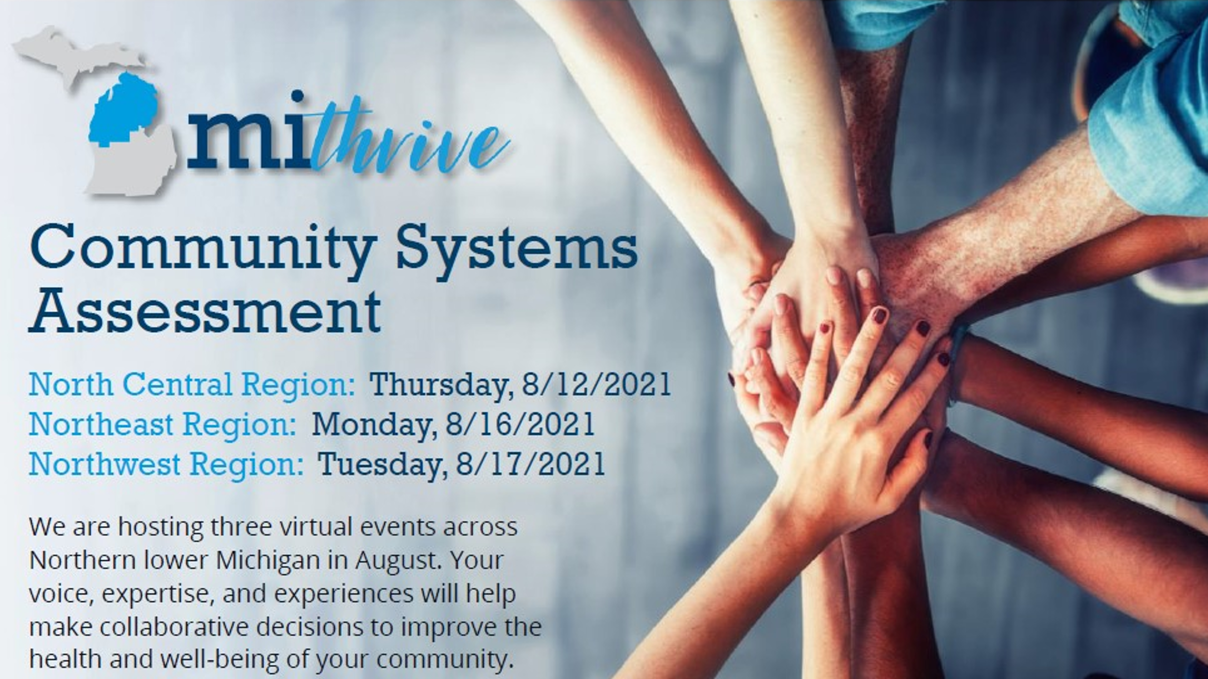
The Community System Assessment focuses on organizations that contribute to wellbeing. It
answers the questions, “What are the components, activities, competencies and capacities in the regional system?” and “How are services being provided to our residents?” It was designed to improve organizational and community communication by bringing a broad spectrum of partners to the same table; explore interconnections in the community system; and identify system strengths and opportunities for improvement. The Community System Assessment was composed of two components: Community System Assessment and subsequent focused discussions at 27 county level community coordinating bodies. A total of 539 residents and partners, representing 199 organizations participated in the Community System Events and/or Focused Discussions in the Northeast, Northwest and North Central Regions.

- Community System Assessment Event

In August, residents and community partners assessed the system’s capacity in the MiThrive Northwest, Northeast, and Northwest Regions. Through a facilitated discussion, they identified system strengths and opportunities for improvement among eight domains. (Please see Appendix E for Community System Assessment Meeting Agenda/Design).

Community System Assessment—System Strengths Summary
Focus Area and Definition | System Strengths  in the Northwest Region
Resources:  A community asset or resource is anything that can be used to improve the quality of life for residents in the community. | - Community connections is in place with SDOH navigation  - No wrong door approach – multiple ways to access resources
Policy:  A rule or plan of action, especially an official one adopted and followed by a group, organization, or government | - Covid has created new partnerships to develop policies  - The Northern Michigan CHIR has gathered agencies to work together
Data Access/Capacity:  A community with data capacity is one where people can access and use data to understand and improve health outcomes | - Assessment tools are gathering more information and breaking the data down geographically
Community Alliances:  Diverse partnerships which collaborate in the community to maximize health improvement initiatives and are beneficial to all partners | - Hundreds of people are engaged in health improvement across the region  - The Northwest Community Health Innovation Region works to empower the local communities to build capacity for health improvement
Workforce:  The people engaged in or available for work in a particular area | - MI Works tracks trending jobs and employment rates  - There is collaboration regarding training opportunities
Leadership:  Leadership is demonstrated by organizations and individuals that are committed to improving the health of the community. | - MiThrive and the Northwest Community Health Innovation Region in collaboration with hospital systems have collaborated to create a shared vision for the community
Community Power/Engagement:  Power is the ability to control the processes of agenda setting, resource distribution, and decision-making, as well as determining who is included and excluded from these processes | - There is significant activity creating awareness of public health issues in the region informed by the CHIR and its Learning Community.  - Organizations are developing and expanding communication plans.
Capacity for Health Equity:  Assurance of the conditions for optimal health for all people | - Organizations in the System are identifying and discussing health disparities

Community System Assessment—System Opportunities for Improvement Summary

Focus Area and Definition | System Opportunities for Improvement  in the Northwest Region | System Opportunities for Improvement  in the Northeast Region
Resources:  A community asset or resource is anything that can be used to improve the quality of life for residents in the community. | - Better communication strategies are needed  - Difficult to understand why people don’t get the services they need due to lack of follow-up | - Organizations need to increase understanding of the reasons that people do not get the services they need.  - The system needs to reduce stigma that may be a barrier to people accessing resources
Policy:  a rule or plan of action, especially an official one adopted and followed by a group, organization, or government | - Must determine ways the System can influence policy  - Be more transparent.  - Review policies before there is an issue with the policy. | - Need to engage in activities that inform the policy development process, organizations in the system need more staff and funding.  - Need to get the decision-makers to the table
Data Access/Capacity:  A community with data capacity is one where people can access and use data to understand and improve health outcomes | - Organizations in the System need to improve on getting information regarding data out in the community  - Improve data sharing | - There are limited resources and manpower  - Need to present the data to the identified target population and tailor the data so it is meaningful to them.  - Update the Community Health Assessment with current information continuously
Community Alliances:  Diverse partnerships which collaborate in the community to maximize health improvement initiatives and are beneficial to all partners | - Need to improve alliances within the whole system  - Partnerships vary from county to county | - There is a need to get community members engaged in partnerships  - The partnerships could improve upon work to improve community health
Workforce:  The people engaged in or available for work in a particular area | - There is a shortage of mental health providers  - Most organizations are short-staffed  - The pay scale is contributing to the shortfall | - The Community System needs to develop an unmet needs report to better understand workforce gaps.  - Use the knowledge from the assessment to develop plans to address workforce gaps and shortfalls.  - Increase wages to create livable wages
Leadership:  Leadership is demonstrated by organizations and individuals that are committed to improving the health of the community. | - Increase emphasis on leadership/management skills  - Innovation leadership acquisition/attract leaders to the region | - More staff are needed to make significant changes.  - Need to help people and organizations with strengths find opportunities for leadership  - The community system needs more diversity in leadership
Community Power/Engagement:  Power is the ability to control the processes of agenda setting, resource distribution, and decision-making, as well as determining who is included and excluded from these processes | - There is a need for more authentic voices and engagement by residents.  - Need to improve feedback loops | - Increase resident voice and engagement to inform decision-making  - Access to broadband is a barrier  - Work collaboratively to link communications plans between organizations.
Capacity for Health Equity:  Assurance of the conditions for optimal health for all people | - Increase development and implementation of equity policies and procedures  - There is a need for more input from residents experiencing disparities  - Goals to reduce disparities are in place as a system, but there is little to no action taken | - Include resident voice to identify health disparities and plan ways to reduce inequities  - Reduce stigma which leads to bias and discrimination against certain populations

Follow up conversations at the local Community Collaboratives and other county level groups
Subsequently, focused conversations were held at county level collaboratives and other cross-sector groups in the NWHD jurisdiction.

Antrim County: Antrim/Kalkaska County Community Collaborative (ACCC) (KCCC)
Collaborative members chose “Community Alliances” as the most important focus area to work on in Antrim and Kalkaska Counties. In the discussion the following themes emerged:
- Seek funding for partnerships and ensure efforts are made for all resources/agencies to be included without duplication
- Pilot or initiate programs where the needs are greatest, not just easiest for the agency to initiate
- Provide support for county-based collaboratives like the KCCC as the central network to identify trends, concerns, assets
- Hold community engagement opportunities where genuine voices can be heard through organic connections
Charlevoix/Emmet County: Charlevoix/Emmet County Community Collaboratives
Collaborative members chose “Community Power/Engagement” as the most important focus area to work on in Charlevoix and Emmet Counties. In the discussion the following themes emerged:
- Increase resident voice
- People are working hard on transportation issues but needs lot of improvement
- Impression that connecting in person results in judgement – need to work on approach, inclusion vs. exclusion of individuals
- Some of the younger people want to connect online versus connecting directly with the organization
- Get people to engage without fear of threat to societal status

Otsego County: Otsego Human Services Network
Otsego County participants chose “Resources” as the most important focus area to work on in Otsego County. In the discussion the following themes emerged:
- Housing, specifically affordable housing is a major need in the area
- Strength: OHSN, Community Foundation, other
- People have limited time, but a lot of experience. Need to figure out a way to get the most bang for buck

- Forces of Change Assessment
The Forces of Change Assessment aims to answer the following questions: “What is occurring or might occur that affects the health of our community or the local system?”, and “What specific threats or opportunities are generated by these occurrences? Like the Community System Assessment, the Forces of Change Assessment was composed of community meetings convened virtually in the Northwest, Northeast, and North Central MiThrive Regions. It focused on trends, factors, and events outside our control within several dimensions, such as government leadership, government budgets/ spending priorities, healthcare workforce, access to health services, economic environment, access to social services, social context, and impact of COVID-19.

(Please see Appendix F for Forces of Change Assessment Event Agenda/Design)
One hundred and forty-one residents and community partners participated in the Forces of Change Assessment in the Northwest, Northeast, and North Central Region in April 2021.

Top Forces of Change in the Northwest, Northeast and North Central MiThrive Regions

Categories of Forces | Top Forces  in Northwest Region | Top Forces  in Northeast Region
Government Leadership  And Spending/Budget Priorities | - Regional and State level approach  - Government’s diversity of priorities  - Community awareness and involvement in decision making | - Political Agendas, Influences and Policies
Sufficient Healthcare Workforce | - Retirement and burnout  - Affordable housing  - Mental health and providers | - Monies & Grants for Training  - Minimum Wage Pending Legislation  - Lack of Staff in Specific Industries (i.e., mental health & substance use disorders)
Access to health services | - Insurance dictates access to healthcare  - Workforce shortages and staffing  - Funding for health services in rural areas | - Cost & Access of Insurance  - Large Poverty & ALICE* population in our region  - Provider shortages & Rurality
Economic environment | - Affordable housing  - Livable wage | - Education and Income Levels  - Affordable Housing  - Broadband Internet
Access to social services | - Mental health and substance misuse  - Affordable housing  - Broadband and skills to navigate virtual platforms | - Lack of housing (public/ affordable)  - Isolation  - Access to SUD services/ treatment facilities (alcohol, vaping, marijuana, prescription drugs)
Social context | - Access to assistance (food, paying utility bills)  - Broadband  - Social justice, equity and inclusion | - Environment and Climate Change  - Access to accurate information / discernment of information  - Affordable housing
Impacts related to COVID-19 | - Rurality, connectivity, transportation, technology, education  - Mistrust  - Mental health | - Vaccinations coming out, recent adverse events  - Overall decrease in mental health  - Closing of businesses, loss of jobs
*ALICE refers to the population in our communities that are Asset Limited, Income Constrained, Employed. The ALICE population represents those among us who are working, but due to childcare costs, transportation challenges, high cost of living and so much more are living paycheck to paycheck.

Data Limitations
Community Health Status Assessment
- Since scores are based on comparisons, low scores can result even from very serious issues, if there are similarly high rates across the state and/or US.
- We can only work with the data we have, which can be limited to the local level in Northern Michigan. Much of the data we have has wide confidence intervals, making many of these data points inexact.
- Some data is missing for some counties - as a result, the “regional average” may not include all counties in the region. Additionally, some counties share data points, for example, in the Michigan Profile for Healthy Youth, data from Crawford, Ogemaw, Oscoda, and Roscommon counties is aggregated therefore each of these counties will have the same value in the MiThrive dataset.
- Secondary data tells only part of the story. Viewing all the assessments holistically is therefore necessary.
- Some data sources have not updated data since the past MiThrive cycle therefore values for some indicators may not have changed and therefore cannot be used to show trends from the last cycle to this cycle.
Community System Assessment
- Completing the Community System Assessment is a means to an end rather than an end in itself. The results of the assessment should inform and result in action to improve the Community System’s infrastructure and capability to address health improvement issues.
- Each respondent self-reports with their different experiences and perspectives. Based on these perspectives, gathering responses for each question includes some subjectivity.
- When completing the assessment at the regional events or at the county level, there were time constraints for discussion and some key stakeholders were missing from the table.
- Some participants tended to focus on how well their organization adressed the focus areas for health improvement rather than assessing the system of organizations as a whole.
Community Themes and Strengths Assessment
- A unique target number of completed CTSA Community Surveys was set for each county based on county population size. Survey responses were not weighted for counties who exceeded this target number.
- While the CTSA Community Survey was offered online and in-person, most surveys were collected digitally.
- Partial responses were removed from the CTSA Community Survey.
- Outreach and promotion for the CTSA Provider Survey was driven by existing MiThrive partners which influenced the distribution of survey responses across provider entities.
- The CTSA Pulse Surveys were conducted across a wide variety of agencies and organizations. Additionally, survey delivery varied including in-person interview, over the phone interview, text survey, and paper format.
- Small survey group sample size is smaller than desired as this data as collected during Pandemic.
Forces of Change Assessment
- Participants self-selected into one of eight Forces of Change Assessment topic areas during the events and discussed forces, trends and events using a standardized Facilitation Guide although facilitators and notetakers differed for the topic areas and events.
- These virtual events removed some barriers for participants although internet accessibility was a requirement to participate.
- When completing the assessment there were time constraints for discussion and some key stakeholders were missing from the table.
- MiThrive staff selected the eight topic areas using the MAPP’s guidance in addition to insights from the MiThrive Core Team members.
- COVID-19 was included as a standalone topic area and all participants were advised of the topic areas and were instructed to focus on their topic area with minimal discussion on COVID-19 unless it was their specific topic area.

Identifying and Prioritizing Strategic Issues
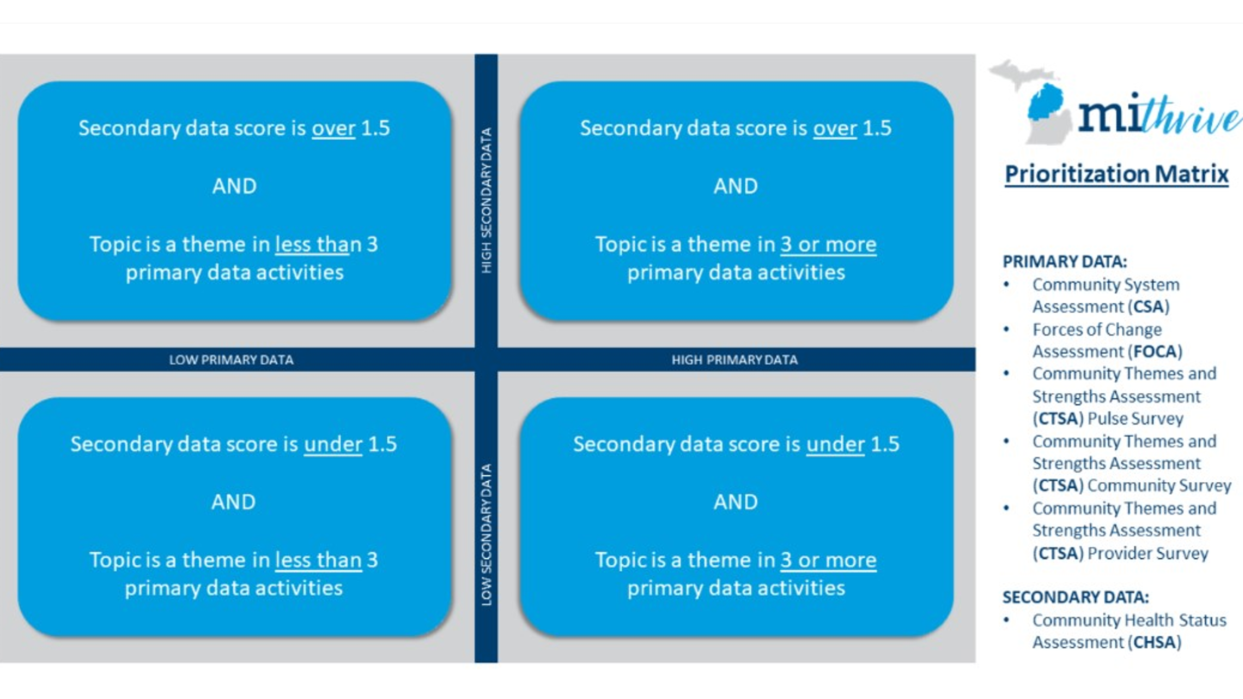
To launch Phase 4, the MiThrive Core Support Team developed the MiThrive Prioritization Matrix (pictured below) to engage in data sensemaking. The Team sorted the data by categorizing the primary and secondary data as either high or low. Secondary data was collected in the Community Health Status Assessment (CHSA) and each indicator was scored on a scale of zero to three. This scoring was informed by sorting the data into quartiles based on the 31-county regional level, comparing to the mean value of the MiThrive Region, and comparing to the state, national, and Healthy People 2030 target when available. Indicators with a score above 1.5 were defined as “high secondary data” and indicators with scores below 1.5 were defined as “low secondary data.” Primary data was collected from the Community System Assessment, Community Themes and Strengths Assessment (Community Survey, Pulse Survey, and Healthcare Provider Survey), and the Forces of Change Assessment. If a topic emerged in three or more primary data activities, it was classified as “high primary data” where topics that emerged in less than three primary data activities were classified as “low primary data.”

On November 16, 2021, MiThrive Design Team members met to sort the data for the Northwest, Northeast, and North Central Regions using the MiThrive Prioritization Matrix. The Team identified where the primary and secondary data converged by clustering data points based on topic, theme, and interconnectedness. Given the interconnectedness of the social determinants of health and health outcomes, some data points were duplicated and represented in numerous clusters. Data clusters that fell into the High Secondary Data/High Primary Data quadrant of the MiThrive Prioritization Matrix were classified as significant health needs.
All of the assessments provide valuable information, but the health needs that occur in multiple data collection methods are the most significant.
There was considerable agreement across the 31-county region, with the following cross-cutting significant health needs sorted into the High Secondary Data/High Primary Data (upper right quadrant) in all three MiThrive Regions:
- Behavioral Health
- Substance Misuse
- Safety and Well-Being
- Housing
- Economic Security
- Transportation
- Diversity, Equity, and Inclusion
- Access to Healthcare
In addition, themes emerged that were unique to each Region:
Northeast Region | Northwest Region
COVID-19 | COVID-19
Healthy weight | Food Security
 | Built Environment

In November, 2021, members of the MiThrive Steering Committee, Design Team, and Workgroups framed the significant health needs identified in each region as Strategic Issues, as recommended by the Mobilizing for Action through Planning and Partnerships Framework. Strategic Issues are fundamental policy choices or critical challenges that must be addressed for a community system to achieve its vision. Strategic Issues should be broad, which allows for the development of innovative, strategic activities as opposed to relying on the status quo, familiar, or easy activities. The broad strategic issues help align the overall community’s strategic plan with the missions and interests of individual community system partners. This facilitated process included MiThrive Partners to review the data clusters as a whole and the individual data points that made up the significant health need.

The 10-11 strategic issues developed for each MiThrive Region(s) that encompass the HDNW Jurisdiction are reflected below in alphabetical order:

Northeast Region Strategic Issues | Northwest Region Strategic Issues
How do we ensure that everyone has safe, affordable, and accessible housing?
How can we increase comprehensive substance misuse prevention and treatment services
that are accessible, patient-centered, and stigma free?
How do we increase access and reduce barriers to quality behavioral health services
while increasing resiliency and wellbeing?
How can we nurture a community and health-oriented transportation environment which provides
safe and reliable transportation access, opportunities, and encouragement to live a healthy life?
How do we foster a community where everyone feels economically secure?
How do we cultivate a community whose policies, systems, and practices
are rooted in equity and belonging?
How do we increase access to integrated systems of care as well as increase engagement, knowledge, awareness with existing systems to better promote health, and prevent and treat chronic disease?
How do we ensure all community members are aware of and can access safety and wellbeing supports?
How do we reduce the impact of Covid-19 on our communities? | How do we foster  infrastructure and opportunities for residents to live healthy lives?
How can we create an environment which provides access, opportunities, and support for individuals to reach and maintain a healthy weight? | What policy, system and  environmental changes do we need to ensure reliable access to healthy food?

In December 2021, 166 residents and community partners participated in the MiThrive Data Walk and Priority Setting Events in each of the three regions, Northeast, Northwest, and North Central. During these live events, participants engaged in a facilitated data walk and participated in a criteria-based ranking process to prioritize 2-3 Strategic Issues to collectively address in a collaborative Community Health Improvement Plan. For each Strategic Issue, a MiThrive Data Brief was prepared that summarized, by MiThrive Region, the results of the four assessments (See Appendix G).
After engaging in the MiThrive Data Walk, participants were asked to complete a prioritization survey to individually rank the Strategic Issues. The ranking process used five criteria to assess each Strategic Issue including severity, magnitude, impact, health equity, and sustainability. Participant votes were calculated in real-time during the event revealing the top scoring Strategic Issues (example scoring grid provided below).
This transparent process elicited robust conversation around the top scoring Strategic Issues and participants identified alignment between the healthy weight Strategic Issue and chronic disease element in the access to healthcare Strategic Issue. Participants opted to combine these two Strategic Issues and wordsmith post event.

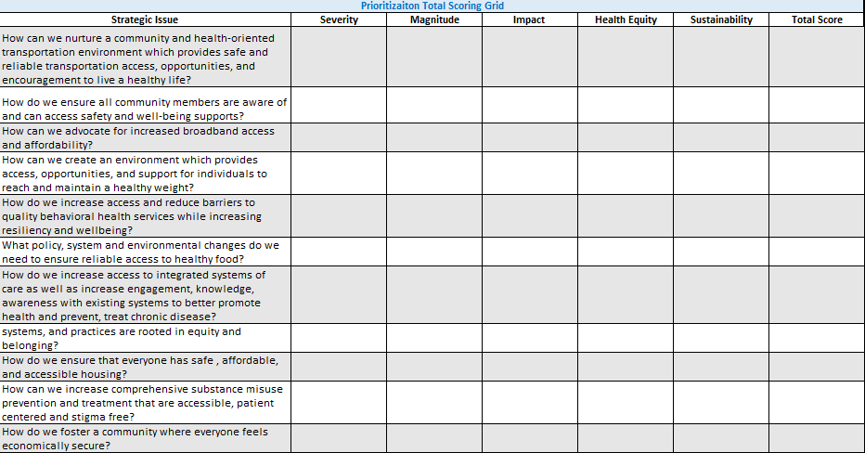
Following the Data Walk and Priority Setting Events, MiThrive partners and participants refined the prioritized Strategic Issues by wordsmithing the combined strategic issues, clarifying the language, and removing any jargon. This process included gathering feedback via a feedback and revision document sent out to MiThrive partners on January 5, 2022. Comments, feedback, and suggestions were collected over the course of a week and half, and the MiThrive Core Support Team updated the top-ranked Strategic Issues based on this feedback.
Key changes, based on revisions, are as follows:
- All three MiThrive Regions separated access to healthcare from chronic disease/healthy weight given the two distinct buckets of work. This change is reflected in the final top-ranked strategic issues below.
- Northeast MiThrive Regions updated the term behavioral health to mental health.
The final top-ranked strategic issues in the MiThrive Regions are as follows:
HDNW Jurisdiction counties are green.
Northeast Region: Alcona, Alpena, Cheboygan, Crawford, Iosco, Montmorency, Ogemaw, Oscoda, Otsego, Presque Isle, and Roscommon.
- How do we increase access to quality substance use disorder services?
- How do we increase access to quality mental health services while increasing resiliency and wellbeing for all?
- How do we reduce chronic disease rates in the region?
- How do we increase access to health care?
Northwest Region: Antrim, Benzie, Charlevoix, Emmet, Grand Traverse, Kalkaska, Leelanau, Manistee, Missaukee, and Wexford.
- How do we ensure that everyone has safe, affordable, and accessible housing?
- How do we increase access to quality mental health and substance use disorder services while increasing resiliency and wellbeing for all?
- How do we increase access to health care?
- How do we reduce chronic disease rates in the region?

Priority Area Narratives
Key data points from the 2021 MiThrive Community Health Assessment for the 4-county Health Department Northwest jurisdiction are briefly discussed below.
Access to Quality Mental Health and Substance Use Disorder Services
Mental health is important to well-being, healthy relationships, and ability to live a full life. It also plays a major role in our ability to maintain good physical health because mental illness increases risk for many chronic health conditions. According to the U.S. Centers for Disease Control and Prevention, mental illness is common in the United States: more than 50% will be diagnosed with a mental illness at some point in their lifetime and one in five Americans will experience a mental illness in a given year, making access to mental health services essential.

Substance misuse impacts peoples’ chances of living long, healthy, and productive lives. It can decrease quality of life, academic performance, and workplace productivity; increase crime and motor vehicle crashes and fatalities; and raise health care costs for acute and chronic conditions.
MiThrive Data Collection Activities
- 100+ secondary data indicators
- Community Survey
- Pulse Survey
- Healthcare Provider Survey
- Community System Assessment
- Forces of Change Assessment
Health care providers across all three MiThrive regions identified substance use as a top issue impacting their patients/clients. This ranked #1 out of 35 issues. Residents in the Northeast Regions identified substance use as a top issue impacting their community. This ranked #1 out of 35 issues. In the Northwest region substance use ranked #2.

A severe shortage of mental health and substance use disorder providers was also identified in the Community Health Status Assessment with the average Health Professional Shortage Area scores for mental health providers being higher than the State (15.02%) in Emmet and Otsego Counties.
Across the HDNW four county region, stigma regarding mental illness and substance use disorders was noted as a barrier to care in the Forces of Change Assessment and the Community System Assessment. This stigma contributes to health disparities for populations experiencing mental illness and/or substance use disorders.

Access to Health Care

Access to health care services affects a person’s health and well-being. It can prevent disease and disability, detect, and treat illness and reduce the likelihood of an early death and increase life expectancy. Access to both physical and mental health services is important for all individuals, regardless of age, and includes factors like insurance status and the ability to cover the cost of care and time and transportation to travel to and from office visits.

Access to care was identified as a top theme in five of six data collection activities in the MiThrive Northeast Region and in six of six data collection activities in the Northwest Region. Access to quality health care services ranked number one among health care providers in the Northwest region and ranked number two among residents in the Northwest region as a top factor for a thriving community. The average HPSA Score for Primary Care exceeds the State rate (14), in Emmet County (13.8). The “sufficient healthcare workforce” and “access to care” were also identified as powerful forces impacting health across all three regions in the Forces of Change Assessment with participants citing rurality, provider access, and affordability of care as negative forces and the increasing use of telehealth as a positive force.

Some individuals and groups face more challenges getting healthcare than others. In the rural areas like the HDNW jurisdiction, doctors and specialists may only be found in larger towns, so many residents must travel long distances to get healthcare. Low-income people and those living in rural areas face more challenges related to transportation, cost of care, difficulty navigating health insurance bureaucracy, inflexibility of work schedules, child-care, and other issues. Lack of cultural competency among healthcare providers can also become a barrier to care. If community residents who are ethnic minorities or identify as LGBTQ+ visit the doctor and perceive discrimination or inadequate understanding of issues that affect them, they may receive inadequate care or delay seeking needed healthcare in the future. Furthermore, people experiencing mental illness or substance use disorders are wary of seeking help as a result of the stigma around mental illness and substance use disorders.
Chronic Disease
According to the US Centers for Disease Control and Prevention, chronic diseases such as heart disease, cancer, and diabetes are the leading causes of death and disability in the US. Leading causes of death in HDNW counties, are, by far, heart disease and cancer (2020, Michigan Department of Health and Human Services). All cancer incidence rates in Antrim, Charlevoix, Emmet, and Otsego counties are slightly lower than the State. Diabetes rates are higher than the State in Antrim, and Otsego Counties. Antrim has a diabetes rate of 11.8%, and Otsego has a rate of 17% compared to 11.7% in the State. Heart disease rates are higher than the State in Antrim and Otsego counties with Antrim County having the highest rate of 135/100,000 versus 104.9/100,000 in the State.

Many chronic diseases are caused by a short list of risk behaviors, such as tobacco use, poor nutrition, lack of physical activity, and excessive alcohol use. In the HDNW, the proportion of obese adults in the HDNW jurisdiction (30.8%) is lower than the State (34.7%) and the proportion of overweight adults in the jurisdiction (39.8%), exceeds the State rate (34.5%). (Source: 2018-2020 Michigan BRFS Regional & Local Health Department Estimates). According to MiThrive data, Charlevoix County has the highest proportion of adult obesity at 35.1% as well as the highest proportion of overweight adults at 41.2%. According to the 2018-2020 Michigan BRFS Regional & Local Health Department Estimates, 21.1% of adults in the HDNW jurisdiction report no leisure time activity as compared to 23.3% in the State of Michigan. Adults reporting current cigarette smoking is lower in the HDNW jurisdiction (14.5%) versus the State (18.6%). Adults reporting heavy drinking in the HDNW jurisdiction is 5.7% compared to the State (6.5%).

Social determinants of health, or the conditions where people live, work and play and include factors like access to care, neighborhood safety, transportation, and greenspaces for physical activity. Social determinants of health are contributing factors to health inequities. For example, people without access to a safe place for physical activity may be more likely to be obese, which raises the risk of other chronic diseases like heart disease and diabetes. Residents in the HDNW jurisdiction noted many barriers to physical activity in the MiThrive Community Survey, including—

- Not enough greenspaces
- Living a great distance from places in the community to engage in physical activity or active transportation.
- Not enough pedestrian paths, trails, or walkways.
- Not enough affordable recreation facilities.
Also, pulse survey respondents ranked “community involvement” as one of the top ways everyone has a chance to live the healthiest life possible.
Safe and Affordable Housing
Safe and affordable housing promotes good physical and mental health. Poor quality or inadequate housing contributes to chronic disease and injuries and can have harmful effects on childhood development. Housing affordability not only shapes home and neighborhood conditions but also affects the overall ability of families to make healthy choices.
Four counties in the HDNW jurisdiction have percentages of people with severe quality problems with housing that are lower than the state (15%). These percentages range from 11% in Charlevoix and Otsego Counties to 12% in Antrim County. In Antrim County (42.4%), the percent of adults whose gross rent is >=35% of household income is higher than the State (40%). All the counties in the HDNW jurisdiction have higher percentages of adults whose gross mortgage is >=35% of household income than the State (17.2%). These percentages range from 17.2% in Charlevoix County to 23% in Emmet County.
According to the Community Survey of residents in the Community Themes and Strengths Assessment, lack of safe and affordable housing was identified as one of the top three issues impacting the community in Antrim, Charlevoix, and Emmet Counties.

Next Steps

Now that the MiThrive Community Health Needs Assessment is complete, MiThrive Workgroups will be developing Community Health Improvement Plans for the top-ranked priorities in their region and overseeing the implementation. The MiThrive Community Health Improvement Plan will serve as the foundation for the HDNW Community Health Improvement Plan, with HDNW incorporating strategies specific to essential local public health services.
It is important to note that the strategies identified by MiThrive represent only one component of the complete plan. No one individual, community group, hospital, agency, or governmental body can be responsible for the health of the community. No one organization can address complex community issues alone. However, working together, we can understand the issues, and create plans to address them. It will be through this combined approach that we will achieve the greatest impact in improving and maintaining the health of our communities and residents.
If you are interested in joining a MiThrive Workgroup, please email mithrive@northernmichiganchir.org.
Definitions
Community Health Improvement Process
The Community Health Improvement Process is a comprehensive approach to assessing community health, including social determinants of health, and developing action plans to improve community health through substantive involvement from residents and community organizations. The community health needs assessment process yields two distinct yet connected deliverables: community health needs assessment report and community health improvement plan/implementation strategy.
Community Health Needs Assessment
Community Health Needs Assessment is a process that engages community members and partners to systematically collect and analyze qualitative and quantitative data from a variety of resources from a certain geographic region. The assessment includes information on health status, quality of life, social determinants of health, mortality and morbidity. The findings of the community health assessment include data collected from both primary and secondary sources, identification of key issues based on analysis of data, and prioritization of key issues.
Community Health Improvement Plan
The Community Health Improvement Plan includes an Outcomes Framework that details metrics, goals and strategies and the community partners committed to implementing strategies for the top priorities identified in Community Health Needs Assessment. It is a long-term, systematic effort to collaboratively address complex community issues, set priorities, and coordinate and target resources.
Health Department Northwest Jurisdiction Implementation Strategy
The Implementation Strategy details which priorities identified in the Community Health Needs Assessment Health Department Northwest plans to address and how it will build on previous efforts and existing initiatives while also considering new strategies to improve health. The Implementation Strategy describes actions HDNW intends to take, including programs and resources it plans to commit, anticipated impacts of these actions, and planned collaboration between HDNW, the hospitals and community partners.

Acknowledgements
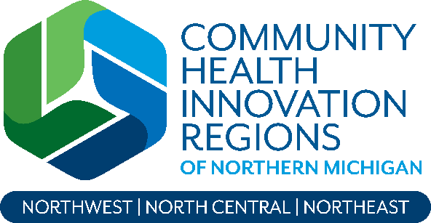
The 2021 MiThrive Community Health Needs Assessment is a regional, collaborative initiative led by the Northern Michigan Community Health Innovation Region (CHIR). It is designed to bring together hospitals, local health departments, community-based organizations, coalitions, agencies, and residents across 31 counties in Northern Michigan to collect data, identify strategic issues, and develop plans for collaboratively addressing them.
The MiThrive Core Team
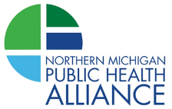
The Northern Michigan Community Health Innovation Region (CHIR) leads the MiThrive community health needs assessment every three years in partnership with hospitals, local health departments and other community partners. The CHIR’s backbone organization is the Northern Michigan Public Health Alliance, a partnership of seven local health departments that together serve a 31-county area. This area was organized into three regions—Northwest, Northeast, and North Central—for the 2021 MiThrive community health needs assessment.
Administrators, communication specialists, epidemiologists, health educators, and nurses from the Northern Michigan Public Health Alliance formed the MiThrive Core Team:
- Jane Sundmacher, MEd, Northern Michigan Community Health Innovation Region and MiThrive Lead
- Erin Barrett, MPH, MCHES, Community Themes and Strengths Assessment Team Lead and North Central Region Lead, District Health Department #10
- Emily Llore, MPH, Forces of Change Assessment Lead and Northwest Region Lead, Health Department of Northwest Michigan
- Donna Norkoli, MCHES, Community System Assessment Team Lead and Northeast Region Lead, District Health Department #10
- Jordan Powell, MPH, Community Health Status Assessment Lead, District Health Department #10
- Scott Izzo, MPH, MA, Community Health Status Assessment Team Member, District Health Department #2
- Amy Horstman, MPH, CHES, Community Health Status Assessment Team Member, Health Department of Northwest Michigan
- Laura Laisure, RN, Grand Traverse County Health Department
- Sarah Oleniczak, MPH, MCHES, District Health Department #10
- Rachel Pomeroy, MPH, CHES, Benzie Leelanau District Health Department
- Anna Reetz, Central Michigan District Health Department
- Devin Spivey, MPH, District Health Department #4

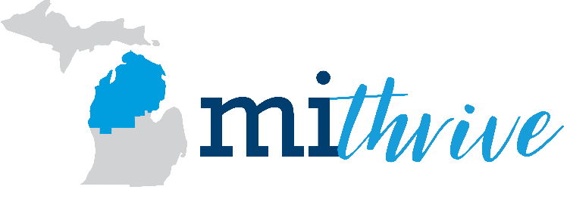
Thank you to all who shared their time and expertise in the MiThrive initiative, especially local residents. Thousands of residents and organizations participated in planning the assessments, participating in community events and surveys, collecting data, analyzying data and ranking strategic issues We are especially grateful to members of the MiThrive Steering Committee and Design Team, as well as the Northwest, Northeast, and North Central Workgroups.
MiThrive Steering Committee
Kerry Baughman, Northwest Michigan Community Action Agency
Rachel Blizzard, McLaren Central Michigan
Arlene Brennan, Traverse Health Center
Ashley Brenner, MidMichigan Health
MiThrive partners represent many sectors of the community, including:
- Residents
- Businesses
- Collaborative bodies and coalitions
- Community-based organizations
- Community mental health agencies
- Federally qualified health centers
- Grant-making organizations
- Hospitals
- Local health departments
- Municipalities
- Michigan Dept of Health and Human Services
- Physicians and other healthcare providers
- Schools
- Substance use prevention, treatment and recovery services
- Tribal Nations
Denise Bryan, District Health Department #2
and District Health Department #4
Dan Buron, Goodwill Northern Michigan
Amy Christie, North County CMH Authority
Sarah Eichberger, Michigan State University Extension
Danielle Gritters, Spectrum Health
Steve Hall, Central Michigan District Health Department
Wendy Hirshenberger, Grand Traverse County Health Department
Kevin Hughes, District Health Department #10
Beth Jabin, Spectrum Health (Chair)
Tanya Janes, McLaren Northern MIchigan
Natalie Kasiborski, PhD, Northern MIchigan Health Consortium
Michelle Klein, Benzie Leelanau District Health Department
Shannon Lijewski, Everyday Life Consulting (Vice-Chair)
Jim Moore, Disability Network of Northern Michigan
Christi Nowak, Munson Healthcare
Lisa Peacock, Benzie Leelanau District Health Department
and Health Department of Northwest Michigan
Erica Phillips, MyMichigan Health
Abby Reeg, Newaygo County Community Collaborative
Lori Schultz, Michigan Department of Health and Human Services
Nicole Smith, Northeast Michigan Community Service Agency
Woody Smith, Avenue ISR

MiThrive Design Team
Ashley Brenner, MyMichigan Health
Danielle Gritters, Spectrum Health
Tanya Janes, McLaren Northern Michigan
Cassie Larrieux, Spectrum Health
Laura Marentette, AuSable Valley CMH Authority
Chrystal Miklosovic, Michigan Department of Health and Human Services
Erica Phillips, MyMichigan Health
Christy Rivette, District Health Department #10
Tara Rybicki, Munson Healthcare
Woody Smith, Avenue ISR
Teresa Tokarczyk, AuSable Valley CMH Authority
Jessica Wimmer, Mecosta Osceola Intermediate School District
David Wingard, PhD, TrueNorth Community Services
MiThrive North Central Workgroup

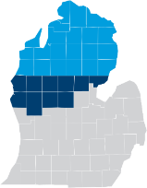

Ashley Brenner, MyMichigan Health
Julie Burrell, The Right Place
Beverly Cassidy, TrueNorth Community Services
Gene Ford, Standard Process
Danielle Gritters, Spectrum Health
Steve Hall, Central Michigan District Health Department
Kevin Hughes, District Health Department #10
Naomi Hyso, Michigan State University Extension
Kelsey Killinger, MyMichigan Health
Cassandre Larrieux, Spectrum Health
Andrea Leslie, Spectrum Health
Scott Lombard, Spectrum Health
Brent Mikkola, MyMichigan Health
Sarah Oleniczak, District Health Department #10
Kaley Petersen, Spectrum Health
Mark Petz, Fremont Area Community Foundation
Beth Pomranky-Brady, Ascension Health
Abby Reeg, Newaygo County Community Collaborative
Lynne Russell, Mason County United Way
Annie Sanders, United Way of Gratiot & Isabella
Monica Schuyler, Pennies from Heaven Foundation
Meredith Sprince, Spectrum Health
Julie Tatko, Family Healthcare
Shawn Washington, Lake County Habitat for Humanity
David Wingard, PhD, TrueNorth Community Services
Jena Zeerip, Spectrum Health

MiThrive Northeast Workgroup
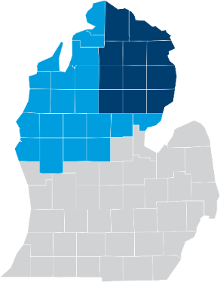

Jodi Balhorn, Northern Michigan Regional Entity
Angie Bruning, Alpena, Montmorency, and Alcona
Great Start Collaborative
Denise Bryan, District Health Department #2 and
District Health Department #4
Dan Connors, Alcona Community Schools
Dawn Fenstermaker, Great Start Collaborative
Cheboygan, Otsego, and Presque Isle Counties
Heather Gagnon, Alpena, Montmorency, and Alcona
Great Start Collaborative
Steve Hall, Central Michigan District Health Department
Amy Hepburn, Thunder Bay Community Health Services
Kevin Hughes, District Health Department #10
Tanya Janes, McLaren Northern Michigan
Kathy Jacobsen, Munson Healthcare
Mary Kushion, Ascension Health
Laura Marentette, AuSable Valley CMH Authority
Lisa Peacock, Health Department of Northwest Michigan
Erica Phillips, MyMichigan Health
Beth Pomranky-Brady, Ascension Health
Tara Rybicki, Munson Healthcare
Jacquelyn Schwanz, Alpena-Montmorency-Alcona ESD
Jordan Smith, Alcona Health Centers
Alice Snyder, Crawford County Commission on Aging
Nena Sork, Northeast Michigan CMH Authority
Nancy Stevenson, Northern Lakes CMH Authority
Patty Thomas, Alcona County Resident
Teresa Tokarczyk, AuSable Valley CMH Authority
Nancy Wright, AuSable Valley CMH Authority

MiThrive Northwest Work Group
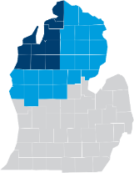

Debbie Aldridge, Benzie-Leelanau District
Health Department
Heidi Britton, Northwest Michigan Health Services, Inc.
Dan Buron, Goodwill Northern Michigan
Jessica Carland, Benzie Bus
Kim Chandler, Munson Healthcare
Kayla Diets, Alcona Health Centers
Sarah Eichberger, Michgan State University Extension
Wendy Hirschenberger, Grand Traverse County
Health Department
Kevin Hughes, District Health Department #10
Kathleen Jakinovich, Health Department of
Northwest Michigan
Tanya Janes, McLaren Northern Michigan
Seth Johnson, United Way of Northwest Michigan
Alyson Kass, Munson Healthcare
Dana Kilinski, Northwest Michigan Health Services, Inc.
Michelle Klein, Benzie-Leelanau District
Health Department
Laura Laisure, Grand Traverse County
Health Department
Paula Martin, Groundworks Center for Resilient Communities
Alison Metiva, Grand Traverse Regional
Community Foundation
Jim Moore, Disability Network of Northern Michigan
Gerry Morris, Project Unity 4 Life
Jenifer Murray, Northern Michigan Community
Health Innovation Region
Donna Norkoli, District Health Department #10
Christy Rivette, District Health Department #10
Tara Rybicki, Munson Healthcare
Rachel Pomeroy, Benzie-Leelanau District
Health Department
Jordan Smith, Alcona Health Centers
Lindsey Schnell, Northwest Michigan Health Services
Madison Smith, Northwest Michigan Health Services
Joshua Stoltz, GrowBenzie
Mindy Taylor, Little Traverse Bay Band of Odawa Indians
Stephanie Williams, Munson Healthcare
Lauren Wolf, Benzie-Leelanau District
Health Department

The following partners contribute funding and leadership to the 2022 MiThrive Community Health Needs Assessment. We are grateful for their support.
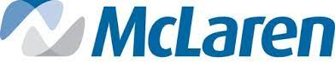
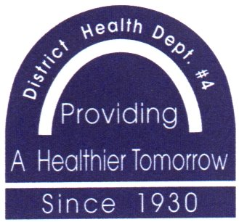
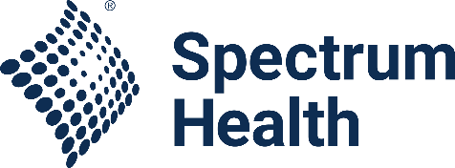
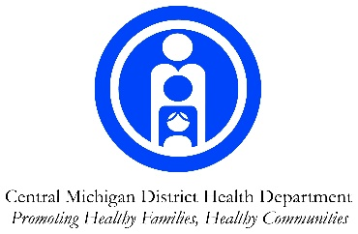

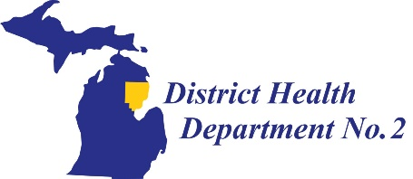
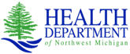

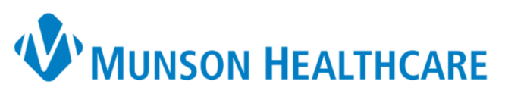

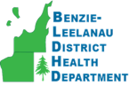
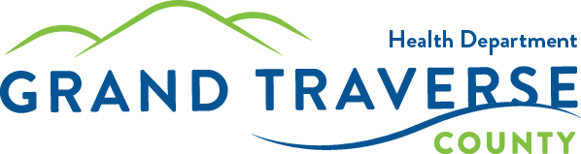
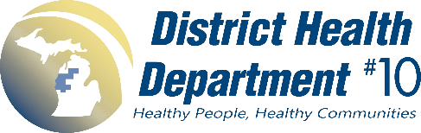

In addition, the Northern Michigan CHIR was awarded two national grants to enhance a health equity focus in the MiThrive assessments:
- Cross Jurisdictional Sharing Mini-Grant from the Center for Sharing Public Health Services to implement the Mobilizing for Action through Planning and Partnerships (MAPP) Process’ Health Equity Supplement

- Increasing Disability Inclusion in the MAPP Process Grant from the National Association of City and County Health Officials.

END OF REPORT

