Post 1. A quote from the recent Mecosta County Substance-use Stigma Assessment stated, “This (substance use disorder) is a public health crisis and the stigma for these individuals needs to be addressed.”

To learn more about Substance-use Disorder, please visit: ShatterProof.org/Learn

For more information about the Mecosta County Substance-use Stigma Assessment, please visit:

Post 2. According to the recent Mecosta County Substance-use Stigma Assessment, 77% of Mecosta County respondents agree that everyone at-risk of witnessing an overdose should be carrying Naloxone.

To learn more about the life-saving benefits of Naloxone go to <https://www.cdc.gov/stop-overdose/caring/naloxone.html>

For more information about the Mecosta County Substance-use Stigma Assessment, please visit:  
  
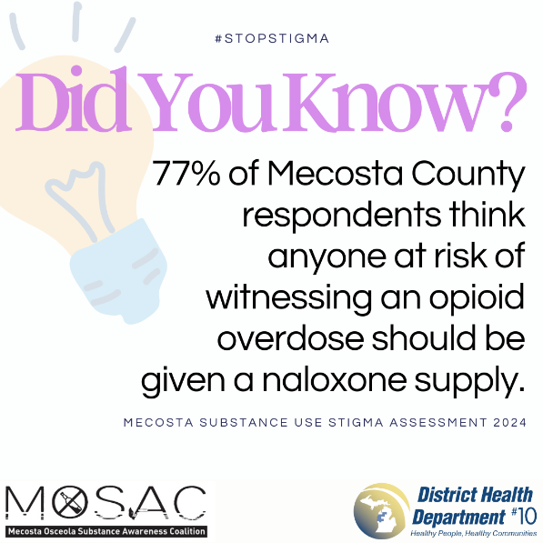

Post 3. According to the recent Mecosta County Substance-use Stigma Assessment, 84% of Mecosta County respondents have a family member or close friend who currently or previously had a substance-use disorder.

For more information about the Mecosta County Substance-use Stigma Assessment, please visit:

**Post 4.** A quote from the recent Mecosta County Substance-use Stigma Assessment shows that stigma is present in the community and affects those with SUD even in recovery.

To learn more about Substance-use Disorder and self-stigma visit: <https://www.naatp.org/combatting-stigma-surrounding-addiction>

For more information about the Mecosta County Substance-use Stigma Assessment, please visit:

**Post 5.** The 2024 Mecosta County Substance-use Stigma Assessment found that 67% of Mecosta County respondents agreed that substance-use disorder is a chronic condition.

Substance-use Disorder should be treated with science and compassion!

To learn more about Substance-use Disorder, please visit: [www.ShatterProof.org/Learn](http://www.ShatterProof.org/Learn)

For more information about the Mecosta County Substance-use Stigma Assessment, please visit:

**Post 6.** What is Shatterproof?

Shatterproof is a National, Nonprofit Organization dedicated to transforming addiction treatment, ending stigma, and supporting communities!

Are you working to #StopStigma? If so, please visit: [www.Shatterproof.org/Our-Work/Ending-Addiction-Stigma](http://www.Shatterproof.org/Our-Work/Ending-Addiction-Stigma)

For more information about the Mecosta County Substance-use Stigma Assessment, please visit:

**Post 7.** A quote from the recent Mecosta County Substance-use Stigma Assessment shows that there is a need for mental health support to prevent SUD.

To learn more about Substance-use Disorder and mental health visit: <https://www.samhsa.gov/mental-health/mental-health-substance-use-co-occurring-disorders>

For more information about the Mecosta County Substance-use Stigma Assessment, please visit:

**Post 9.** #DidYouKnow #DYK that Words Hold Power?

Check out Shatterproof and help us reduce substance-use disorder stigma: <https://www.shatterproof.org/our-work/ending-addiction-stigma/change-your-language>

For more information about the Mecosta County Substance-use Stigma Assessment, please visit:

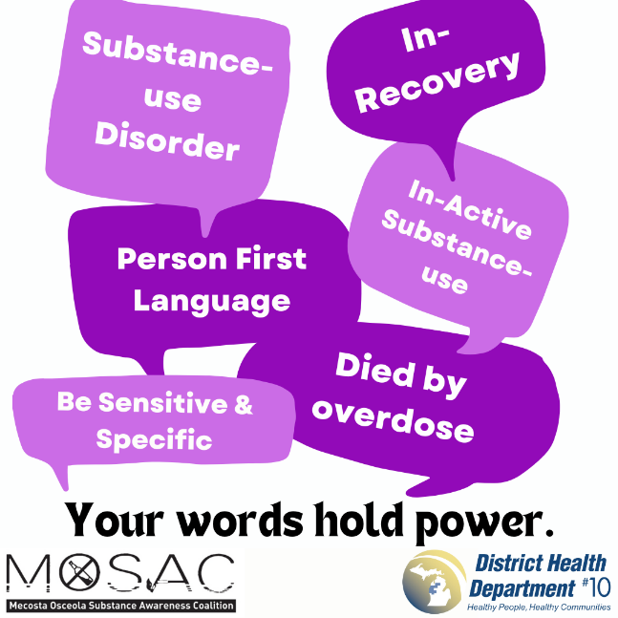

**Post 10.** #DidYouKnow #DYK that stigmatizing language impacts an individual’s ability to search for treatment or resources for their substance-use disorder?

Check out Shatterproof and help us reduce substance-use disorder stigma: <https://www.shatterproof.org/our-work/ending-addiction-stigma/change-your-language>

For more information about the Mecosta County Substance-use Stigma Assessment, please visit:

**Post 11.** The 2024 Mecosta County Substance-use Stigma Assessment found that 99% of Mecosta County respondents agree that individuals with substance-use disorders can, with treatment, get well and return to productive lives.

For more information regarding recovery from SUD go to: <https://www.shatterproof.org/learn/addiction-recovery>

For more information about the Mecosta County Substance-use Stigma Assessment, please visit:

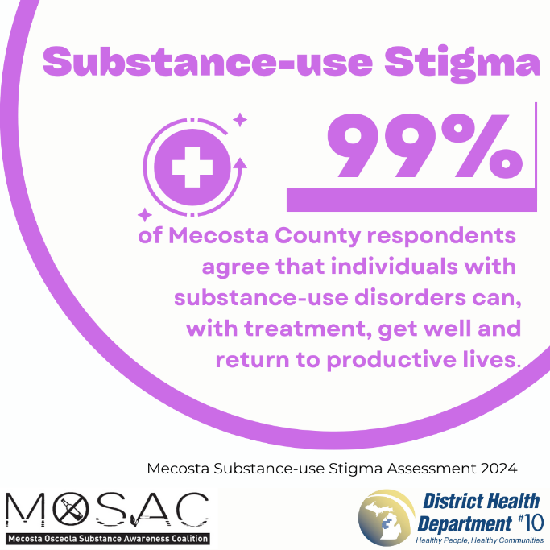

**Post 12.** #DidYouKnow #DYK that if a stranger was having an overdose, 98% of Mecosta County respondents stated they would help?

To locate free Naloxone in your county: <https://acrobat.adobe.com/id/urn:aaid:sc:VA6C2:04924789-c1fc-4b75-9ac5-754a27309db2>

For more information about the Mecosta County Substance-use Stigma Assessment, please visit:

**Post 13.** #DidYouKnow #DYK that syringe service programs:

* reduce HIV prevalence by as much as 50%
* Reduce hepatitis C prevalence by as much has 50%
* Increase access to substance use disorder treatment and recovery services

For more information about syringe service programs visit: <https://www.dhd10.org/men-women/syringe-service-program-ssp/>

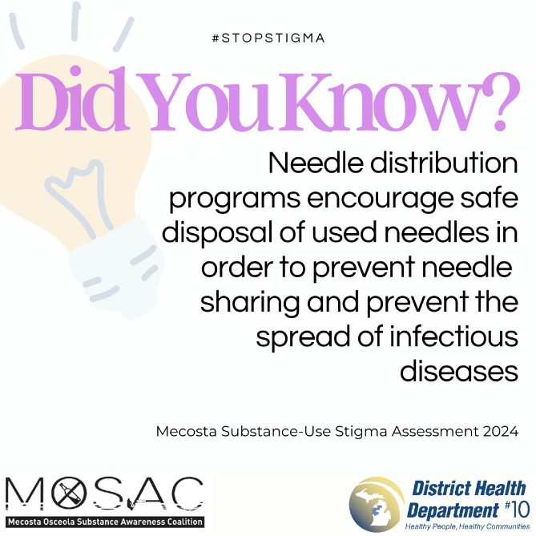

**Post 14.** The 2024 Mecosta County Substance-use Stigma Assessment found that 3 out of 5 Mecosta County respondents know a family member of close friend who has faced stigma or discrimination due to a substance-use disorder.

It is not your fault! The truth is - self-stigma can be as harmful as addiction itself.

For more information about different types of stigma, please visit: <https://www.shatterproof.org/our-work/ending-addiction-stigma/understanding-addiction-stigma>

#StopStigma #MecostaCountyMI #SubstanceUseDisorder

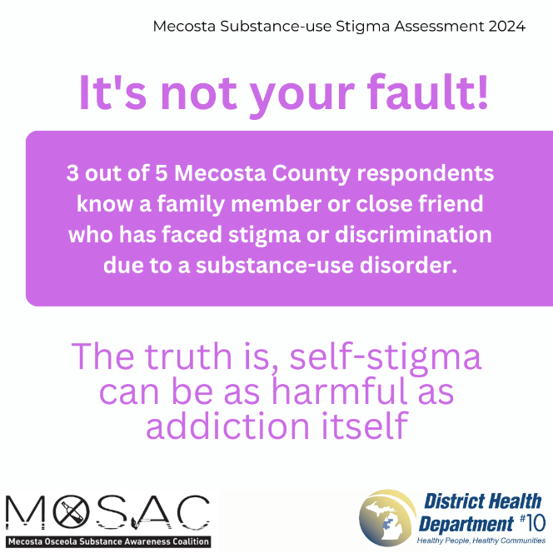

**Post 15.** Nearly 49 million Americans are living with addiction, but many don’t get the treatment they need. It doesn’t have to be this way. We have the power to change things. Lasting change is only possible if we work together. (Source: Shatterproof)

For more information on education and advocacy to prevent substance use disorder and promote recovery visit: <https://www.shatterproof.org/our-work/educating-and-empowering-communities>

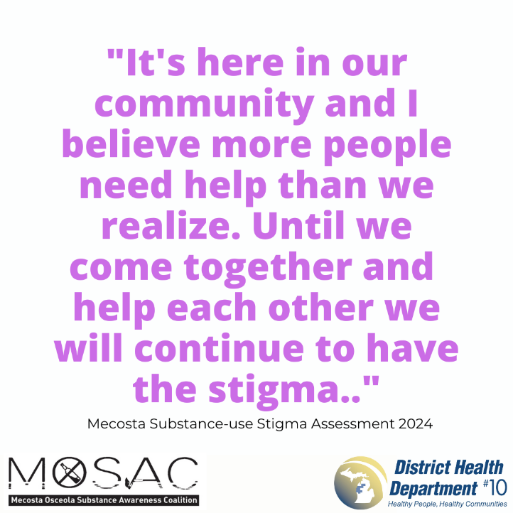

**Post 16.** According to the 2024 Mecosta County Substance Use Stigma Assessment, almost 9 out of 10 survey respondents support harm reduction services.

For more information about Harm Reduction Services, please visit: <https://harmreduction.org/about-us/principles-of-harm-reduction/>   
  
#StopStigma #MecostaCountyMI #SubstanceUseDisorder #HarmReductionSavesLives

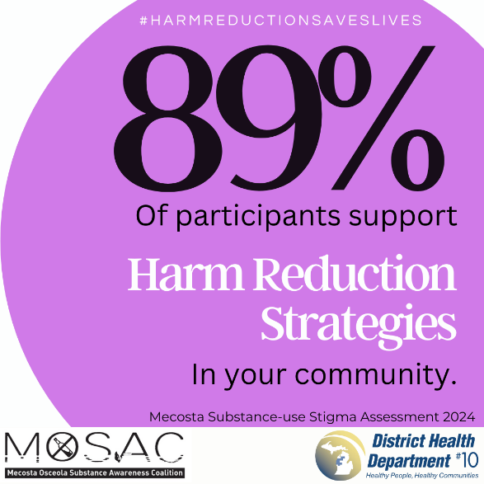

**Post 17.** The 2024 Mecosta County Substance-use Stigma Assessment found that 76% of Mecosta County respondents support syringe service programs in their community.

For more information about local harm reduction services, please visit: <https://www.dhd10.org/men-women/syringe-service-program-ssp/>

#StopStigma #MecostaCountyMI #SubstanceUseDisorder #FightSubstanceUseDisorderStigma

**Post 18.** Needle distributionprograms are community prevention programs that provide a range of services that prevent spread of disease and protect communities. They are proven to save lives, help those with substance use disorders get needed support, prevent overdose deaths, and reduce the impact of drug use on the community.

For more information visit: <https://www.cdc.gov/syringe-services-programs/php/index.html#:~:text=Syringe%20services%20programs%20are%20community,drug%20use%20on%20the%20community>.

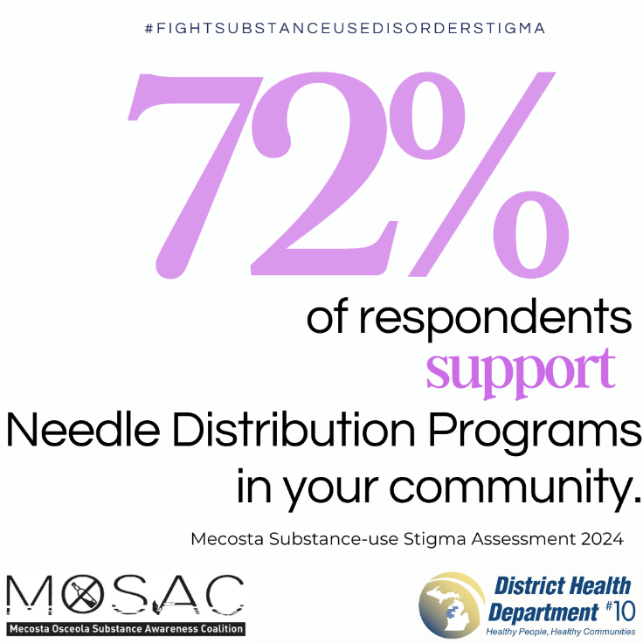

**Post 19**. A quote from the recent Mecosta County Substance-use Stigma Assessment stated: “It’s here in our community and I believe more people need help than we realize.

To learn more about the words family, providers, and others should use to avoid stigmatizing people with substance use disorder [click here](https://www.youtube.com/watch?v=mCf7jXHYSSI).

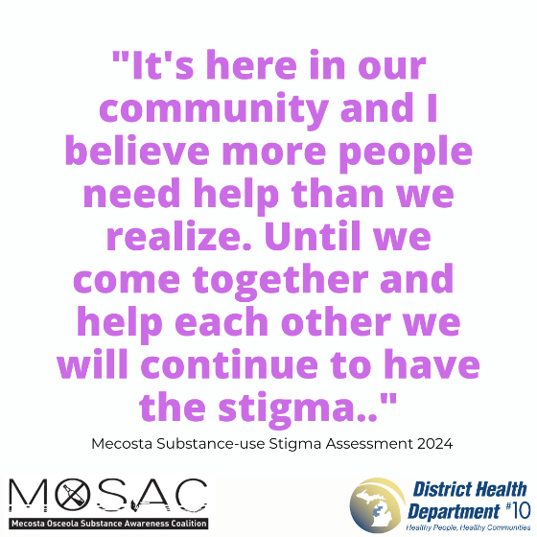

**Post 20**. Stigma against substance use disorders can often make those affected feel alone or isolated in their struggle. This isolation can compound the issue and make it even harder for people to seek treatment and recover. A necessary step towards ending stigma is creating spaces and communities that are more inclusive and accepting.

See this [video](https://youtu.be/e3TgHZyMv_c) developed by the Central Michigan Recovery Education Network.

